ORNL/CDIAC-154
NDP-089

CARBON DIOXIDE, HYDROGRAPHIC, AND CHEMICAL DATA OBTAINED DURING THE R/V Knorr REPEAT HYDROGRAPHY CRUISES IN THE NORTH ATLANTIC OCEAN:
CLIVAR CO₂ SECTIONS A20_2003 (22 SEPTEMBER–20 OCTOBER, 2003) AND
A22_2003 (23 OCTOBER–13 NOVEMBER, 2003)

Contributed by
R. A. Feely,¹ C. L. Sabine,¹ F. J. Millero,² A. G. Dickson,³ R. A. Fine,² C. A. Carlson,⁴
J. Toole,⁵ T. M. Joyce,⁵ W. M. Smethie,⁶ A. P. McNichol,⁵ and R. M. Key⁷

¹ Pacific Marine Environmental Laboratory, NOAA, Seattle, WA
²Rosenstiel School of Marine and Atmospheric Science, University of Miami, Miami, FL
³Scripps Institution of Oceanography, University of California, San Diego
⁴University of California, Santa Barbara, CA
⁵Woods Hole Oceanographic Institution, Woods Hole, MA
⁶Lamont-Doherty Earth Observatory, Columbia University, Palisades, NY
⁷Princeton University, Princeton, NJ

Prepared by
Alex Kozyr
Carbon Dioxide Information Analysis Center
Oak Ridge National Laboratory
Oak Ridge, Tennessee, USA

Date Published: September 2008

Prepared for the Climate Change Research Division
Office of Biological and Environmental Research
U.S. Department of Energy
Budget Activity Numbers KP 12 04 01 0 and KP 12 02 03 0

Prepared by the
Carbon Dioxide Information Analysis Center
OAK RIDGE NATIONAL LABORATORY
Oak Ridge, Tennessee 37831-6335
managed by
UT-BATTELLE, LLC
for the
U.S. DEPARTMENT OF ENERGY
under contract DE-AC05-00OR22725
TABLE OF CONTENTS

LIST OF FIGURES v
LIST OF TABLES v
ABBREVIATIONS AND ACRONYMS vii
ABSTRACT ix
1. BACKGROUND INFORMATION 1
2. DESCRIPTION OF THE EXPEDITION 4
2.1 R/V Knorr: Technical Details and History 4
2.2 R/V Knorr A20_2003 and A22_2003 Cruise Information 4
2.3 Parameters Measured, Participating Institutions, and Responsible Investigators 6
3. DESCRIPTION OF VARIABLES AND METHODS 7
3.1 Hydrographic Measurements 7
3.2 Total CO₂ Measurements 8
3.3 Total Alkalinity Measurements 9
3.3.1 Section A20_2003 9
3.3.2 Section A22_2003 12
3.4 Dissolved Organic Carbon Measurements 25
3.5 Total Dissolved Nitrogen Measurements 26
3.6 Chlorofluorocarbon Measurements 26
3.6.1 Sample Collection 26
3.6.2 RSMAS Equipment and Technique 27
3.6.3 Lamont-Doherty Earth Observatory Equipment and Technique 27
3.6.4 Calibration 27
3.7 ¹⁴C and ¹³C Measurements 28
4. HOW TO OBTAIN THE DATA AND DOCUMENTATION 33
5. REFERENCES 35

LIST OF FIGURES

1 Cruise tracks for the Atlantic Ocean sections A20_2003 and A22_2003 2
2 Plot of the deviations of analyses of reference materials (Batch 60 and Batch 61) from the
certified values (∆ = measured value – certified value). Values depicted by open circles are considered “outliers” 11
3 Auto-titration system used during the section A22_2003 Cruise 13
4 Titration cell diagram 14
5 Deviation between the TALK and CRM for both systems. 15
6 Deviation between the TCO₂ and CRM for both systems 16
7 Deviation between the pH and CRM for both systems 16
8 Difference between the TCO₂ of the SOMMA and TALK system results 17
9 Deviation of TALK on duplicate samples 18
10 Deviation of TCO₂ on duplicate samples. 18
11 Deviation of pH on duplicate samples 19
12 Difference in calculated and measured TALK using an input of pH and TCO₂ 20
13 Difference in calculated and measured TCO₂ using an input of TALK and pH 20
14 Difference in calculated and measured pH using an input of TALK and TCO₂ 21
15 Surface measurements of salinity versus latitude from the 1997 and 2003 cruises 22
16 Surface measurements of temperature versus latitude from the 1997 and 2003 cruises. 22
17 Surface measurements of NTA versus latitude from the 1997 and 2003 cruises 23
18 Surface measurements of NTCO₂ versus latitude from the 1997 and 2003 cruises 23
19 Surface measurements of in situ pH versus latitude from the 1997 and 2003 cruises 24
20 Surface measurements of in situ pCO₂ versus latitude from the 1997 and 2003 cruises 24
21 Surface measurements of ¹⁴C versus longitude from the 1997 and 2003 cruises (A20) 29
22 Surface measurements of ¹⁴C versus longitude from the 1997 and 2003 cruises (A22) 30
23 Surface measurements of ¹³C versus longitude from the 1997 and 2003 cruises (A20) 30
24 Surface measurements of ¹³C versus longitude from the 1997 and 2003 cruises (A22) 31

LIST OF TABLES

1 Technical characteristics of the R/V Knorr 5
2 Parameters measured, responsible investigator, and associated institution 6
3 Listing of equipment used for alkalinity titrations for A20_2003 cruise 10
4 Summary of certified reference material measurements 15
5 Summary of duplicate measurements 17
6 Summary of internal consistency deviations 19

ABBREVIATIONS AND ACRONYMS
AMC accelerator mass spectrometry
CDIAC Carbon Dioxide Information Analysis Center
CFC chlorofluorocarbon
CLIVAR Climate Variability (Program)
CO₂ carbon dioxide
CRM certified reference material
CTD conductivity, temperature, and depth
DOC dissolved organic carbon
DOE U.S. Department of Energy
ECD electron capture detector
EXPOCODE expedition code
GC gas chromatograph
HCFC hydrochlorofluorocarbon
NDP numeric data package
NOAA National Oceanic and Atmospheric Administration
NO nitric oxide
NOSAMS National Ocean Sciences Accelerator Mass Spectrometry Facility
NSF National Science Foundation
ODF Oceanographic Data Facility
PMEL Pacific Marine Environmental Laboratory
RSMAS Rosenstiel School of Marine and Atmospheric Science
R/V research vessel
SIO Scripps Institution of Oceanography
SOMMA single-operator multi-parameter metabolic analyzer
TALK total alkalinity
TDN total dissolved nitrogen
TCO₂ total inorganic carbon
WHP WOCE Hydrographic Program
WOCE World Ocean Circulation Experiment

ABSTRACT
Feely R. A., C. L. Sabine, F. J. Millero, A. G. Dickson , R. A. Fine, C. A. Carlson, J. Toole,T. M. Joyce, W. M. Smethie, A. P. McNichol, and R. M. Key. 2008. Carbon Dioxide, Hydrographic, and Chemical Data Obtained During the R/V Knorr Repeat Hydrography Cruise in the Atlantic Ocean: CLIVAR CO₂ Sections A20_2003 (22 September–20 October 2003) and A22_2003 (23 October–13 November, 2003). Ed. A. Kozyr. ORNL/CDIAC-154, NDP-089. Carbon Dioxide Information Analysis Center, Oak Ridge National Laboratory, U.S. Department of Energy, Oak Ridge, Tennessee, 46 pp.

This report presents methods, and analytical and quality control procedures for salinity, oxygen, nutrient, inorganic carbon, organic carbon, chlorofluorocarbon (CFC), and bomb carbon-14 system parameters performed during the A20_2003 and A22_2003 cruises, which took place between September 22 and November 13, 2003, aboard research vessel (R/V) Knorr under the auspices of the National Oceanic and Atmospheric Administration (NOAA) and National Science Foundation (NSF). The R/V Knorr departed Woods Hole, Massachusetts, on September 22 for the Repeat Section A20, and ended this line in Port of Spain, Trinidad, on October 20. The Repeat Section A22 started on October 23 in Port of Spain, Trinidad, and finished on November 13, 2003, in Woods Hole, Massachusetts. The research conducted was one of a series of repeat hydrography sections jointly funded by NOAA and NSF as part of the Climate Variability Program (CLIVAR)/CO2/repeat hydrography/tracer program. Samples were taken from 36 depths at 88 stations on section A20 and 82 stations on section A22.
The data presented in this report include the analyses of water samples for total inorganic carbon (TCO₂), total alkalinity (TALK), dissolved organic carbon (DOC), CFC, carbon-14, hydrographic, and other chemical measurements.
The R/V Knorr A20_2003 and A22_2003 data sets are available free of charge as a numeric data package (NDP) from the Carbon Dioxide Information Analysis Center (CDIAC). The NDP consists of the oceanographic data files and this printed documentation, which describes the procedures and methods used to obtain the data.
Keywords: carbon dioxide, total CO₂, total alkalinity, carbon cycle, coulometry, potentiometry, hydrographic measurements, CLIVAR, Atlantic Ocean

BACKGROUND INFORMATION
The cruise of research vessel (R/V) Knorr along the World Ocean Circulation Experiment (WOCE) designated sections A20 and A22 from Woods Hole, Massachusetts, to Port of Spain, Trinidad, and back to Woods Hole were the part of the Climate Variability (CLIVAR) Carbon Dioxide and Repeat Hydrography Section Project, sponsored by the National Oceanic and Atmospheric Administration (NOAA) and National Science Foundation (NSF). The goal of the Repeat Hydrogaphy Project is to measure decadal changes in circulation, heat and fresh water budgets, and carbon inventory in the ocean. The cruises repeat a subset of the WOCE Hydrographic Program (WHP) and Joint Global Ocean Flux Study lines occupied in each major ocean basin in the 1990s.
The WOCE/WHP program is driven by the need to monitor the increases in carbon dioxide (CO₂) in the ocean and provide the necessary data to support continuing model development that will lead to improved forecasting skills for oceans and global climate. During the 1990s, the WOCE/Joint Global Ocean Flux Study (JGOFS) provided a full-depth baseline data set against which to measure future changes. By integrating the scientific needs of programs requiring measurement of the full water column, major synergies and cost savings are achieved. These measurements are of importance both for major research programs, such as CLIVAR and the U.S. Global Climate Research Project Ocean Carbon and Climate Change Program, and for operational activities such as the Global Ocean Observation System and the Global Climate Observing System. As outlined in the program documentation, one component of a global observing system for the physical climate/CO₂ system should include periodic observations of hydrographic variables, CO₂ system parameters, and other tracers. The large-scale observation component of the Ocean Carbon and Climate Change Program needs systematic observations of the invasion of anthropogenic carbon in the ocean that is superimposed on a variable natural background. The five topical areas addressed by the CO₂/CLIVAR repeat hydrography program are

1. carbon system studies;
2. heat and freshwater storage and flux studies;
3. deep and shallow water mass and ventilation studies;
4. calibration of autonomous sensors; and
5. data for model calibration.

R/V Knorr cruise 173 was conceived to reoccupy two meridional hydrographic sections in the western North Atlantic as part of the CLIVAR/Global Carbon Program of repeat hydrography. Section A20, which lies nominally along 52° 20’ W, was sampled during leg 1 of the cruise. The return leg to Woods Hole reoccupied section A22 along 66° W (Fig. 1). Meridional hydrographic sections near 52° W had been made on three occasions prior to this cruise: in the 1950s, 1980s, and in 1997. The sampling plan for the 2003 occupation of both sections was simply to make a full-depth hydrographic station at each site sampled in 1997 (see NDP-082 at: http://cdiac.ornl.gov/oceans/ndp_082/ndp082.html). The extremely tight station spacing at the northern end of the sections done in 1997 was relaxed slightly in 2003.
This data report focuses on the measurements of total carbon dioxide (TCO₂), total alkalinity (TALK), dissolved organic carbon (DOC), chlorofluorocarbons (CFC-11 and CFC-12), carbon-14 (¹⁴C), nitrate (NO₃), nitrite (NO₂), phosphate (PO₄), silicate (SiO₄), salinity, and dissolved oxygen (O₂).
The methodology, instrumentation, and standardization of these parameters have improved significantly during the WOCE/JGOFS era. Notable developments include the release of manuals detailing the analytical methods and operating protocols (DOE 1994, PICES 2007). Certified reference materials (CRMs) are now available for TCO₂ and TALK, analyses for which are run interspersed with samples to determine calibration offsets. For this cruise, the TALK and TCO₂ values were adjusted to account for the small difference between the CRMs run at sea and the certified value determined at Scripps Institution of Oceanography (SIO). The TCO₂ coulometers were calibrated daily by injecting aliquots of pure CO₂ (99.995%). The stability of each coulometer cell solution was confirmed with the analyses of several CRMs each day.

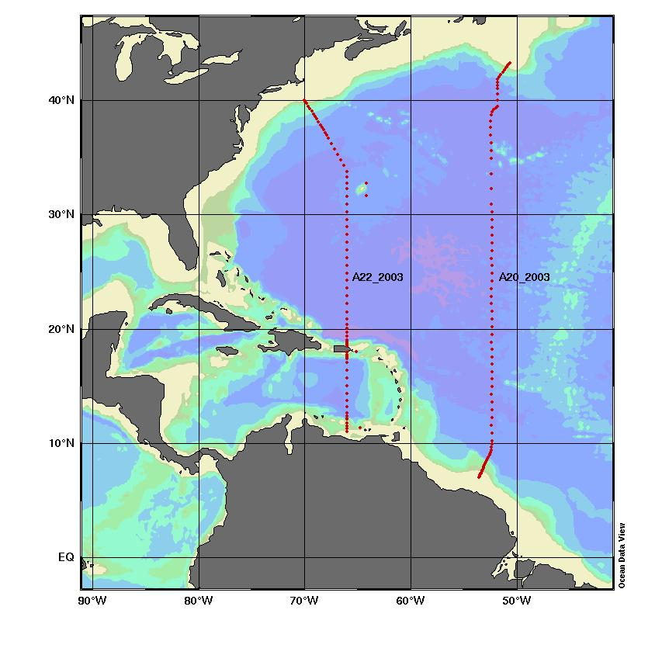
Fig. 1. Cruise tracks for the Atlantic Ocean sections A20_2003 and A22_2003.

Instrumentation has improved in the last decade. Alkalinity measurements can be done with better precision through automation and close checks of the response of electrodes. Burettes are independently calibrated, and the preparation of titrant (hydrochloric acid) has undergone improved quality control and standardization (Millero et al. 1998). The TCO₂ measurements are done by coulometry, a precise integrative method. During the cruise two single-operator multiparameter metabolic analyzers (SOMMAs) (Johnson et al. 1999) PMEL-1 and PMEL-2 were used for analyses, which facilitated a sample throughput of up to 80 per day. Oxygen measurements were performed by Winkler titrations (Carpenter 1965) with photometric endpoint detection (Friederich, Sherman, and Codispoti 1984).
The data underwent careful quality assurance and quality control both during and after the cruise. The precision of the measurements was determined from duplicate sampling and comparison of data from deep water, where little variability is expected. Outliers in the data were flagged based on several methods using prior knowledge of the trends and known relationships between parameters. Depth profiles for each parameter were scrutinized for outliers. When deviations were observed, other parameters were assessed to determine whether they showed deviations as well.
This report describes procedures and methods for hydrographic measurement and the analytical procedures, calculations, and assessment of precision for nutrient, oxygen, TCO₂, TALK, CFCs, ¹⁴C, and DOC measurements.

2. DESCRIPTION OF THE EXPEDITION

2.1 R/V Knorr: Technical Details and History
The R/V Knorr, built in 1969 by the Defoe Shipbuilding Company in Bay City, Michigan, is owned by the U.S. Navy. It was turned over to the Woods Hole Oceanographic Institution (WHOI) in 1971 for operation under a charter agreement with the Office of Naval Research. It was named for E. R. Knorr, a hydrographic engineer and cartographer who in 1860 held the title of Senior Civilian and Chief Engineer Cartographer of the U.S. Navy Office. Its original length and beam were 245 and 46 ft, respectively. Beginning on February 6, 1989, it underwent a major midlife retrofit or “jumbo-izing” at the McDermott Shipyard in Amelia, Louisiana. A midsection was added to the ship to stretch its length by 34 ft, to 279 ft, and fore and aft azimuthing propulsion systems were added to make it one of the most maneuverable and stable ships in the oceanographic fleet. By the time it was returned to WHOI in late 1991, it had undergone retrofitting for 32 months. The WOCE section P6 was the vessel’s first post-retrofit scientific cruise. The R/V Knorr was designed for a wide range of oceanographic operations and possesses antiroll tanks and a strengthened bow for duty in icy waters. Like its sister ship, the R/V Melville, it is used for ocean research and routinely carries scientists from many different countries. Table 1 provides a list of technical characteristics of the R/V Knorr.

2.2 R/V Knorr A20_2003 and A22_2003 Cruise Information

Ship name | Knorr
EXPOCODEs | 316N20030922 and 316N20031023
CLIVAR section | A20_2003 and A22_2003
Ports of call | Woods Hole, MA→Port of Spain, Trinidad→Woods Hole, MA
Dates | September 22–October 20, 2003; October 23–November 13, 2003
Funding support | NOAA, NSF
Chief scientists | Dr. John Toole/WHOI  Dr. Terrence M. Joyce/WHOI

Table 1. Technical characteristics of the research vessel Knorr
Ship name: R/V Knorr
Call sign: KCEJ

Basic dimensions:
Gross registered tonnage 2518 T Displacement 2958 LT
Overall length 279 ft Beam 46 ft
Draught (maximum) 16.5 ft Service speed 12 kn
Maximum speed 14.5 kn Minimum speed 0.1 kn
Main deck clear length 126 ft

Personnel: Crew 24
Scientists 34

Main engine: 4 × Mak6M 322 = 4 × 1000 kW at 750 rpm

Propulsion: Twin lips diesel-electric, azimuthing stern thrusters, 1500 SHP

Bow thruster: Lips retractable azimuthing 900 SHP

Fuel capacity: 160,500 gal

Maximum cruise duration: 60 days (12,000 nm)

Nautical equipment: Integrated navigation system
Potable water generator
2 instrument hangars
Winches: 1 heavy-duty trawl with 30,000 ft of ½-in. wire
2 hydrographic, both with 30,000 ft of hydrowire
Hydraulic cranes on the starboard side aft and midships
Scientific storage space of 1,320 ft²
Portable van space
Machine shop
Fume hoods
Uninterruptible power supply
Air conditioning
Library/lounge
3680 ft² of laboratory space for multidisciplinary research

2.3 Parameters Measured, Participating Institutions, and Responsible Investigators
Table 2 shows the parameters that were measured on the cruise of R/V Knorr as part of the CLIVAR Carbon Dioxide and Repeat Hydrography section project sponsored by NOAA and NSF.

Table 2. Parameters measured listed with responsible investigator and associated institution
Parameter | Institution | Responsible Investigator
Conductivity, temperature, and depth | Scripps Institution of Oceanography (SIO) | F. Delahoyd
Acoustic and lowered acoustic Doppler current profile | University of Hawaii | E. Firing/J. Hummon
Salinity | SIO | J. Swift
Nutrients | SIO | J. Swift
Dissolved oxygen | SIO | J. Swift
Chlorofluorocarbons | Lamont-Doherty Earth Observatory /University of Miami | W. Smethie/R. Fine
Tritium, helium | Woods Hole Oceanographic Institution (WHOI) | W. Jenkins
Total carbon dioxide | Pacific Marine Environmental Laboratory (PMEL) | R. Feely/C. Sabine
Total alkalinity | University of Miami/SIO | F. Millero /A. Dickson
Dissolved organic carbon | University of California at Santa Barbara (UCSB) | C. Carlson
Total dissolved nitrogen | University of California at Santa Barbara (UCSB) | C. Carlson
Chromophoric dissolved organic matter | University of California at Santa Barbara (UCSB) | N. Nelson
¹³C | University of Washington | P. Quay
¹⁴C | WHOI/Princeton University | A. McNichol/R. Key

3. DESCRIPTION OF VARIABLES AND METHODS

3.1 Hydrographic Measurements
Samples for CFCs, helium isotopes (³He), oxygen (O₂), hydrochlorofluorocarbon (HCFCs), TCO₂, TALK, radiocarbon (Δ¹⁴C), tritium, DOC, chromophoric dissolved organic matter, TDN, salinity, and nutrients were drawn in this sequence from a conductivity, temperature, and depth (CTD) sampling package containing thirty-six 12-L Bullister bottles. A detailed description of methods for the CTD data, lowered acoustic Doppler current profile data, and bio-optical data are given in the cruise reports at http://whpo.ucsd.edu/data_access?ExpoCode=316N200309 for the section A20_2003 and http://whpo.ucsd.edu/data_access?ExpoCode=316N200310 for the section A22_2003.
In all, 2,530 bottle salinity samples were taken during the cruise along A20 section and 2,493 samples measured along section A22. Samples were drawn from the 12-L Bullister bottles into 250-mL Kimax borosilicate bottles. The bottles were rinsed at least three times before being filled to approximately 220 mL. A plastic insert and Nalgene cap were used to seal the sample in the bottle. At the conclusion of sampling, the time was noted and samples were placed into the salinometer lab so they could equilibrate to room temperature. Samples were analyzed after a period of at least 10 h and typically not more than 24 h from the time of sampling. Two Guildline Autosal Model 8400A salinometers (S/N 57-263 and 57-266) were used on section A20, and a single Guildline Autosal Model 8400A salinometer (S/N 48-266) was used on section A22. They were located in the forward analytical lab and were used for measuring salinity on all stations. The salinometers were modified by SIO Oceanographic Data Facility (ODF) to contain an interface for computer-aided measurement. The water bath temperatures were set and maintained at a value near the laboratory air temperature 24°C for the entire leg. For more information on salinity measurements, see the A20_2003 and A22_2003 cruise reports.
Dissolved oxygen analyses were performed with an ODF-designed automated oxygen titrator using photometric end-point detection based on the absorption of 365-nm wavelength ultra-violet light. The titration of the samples and the data logging were controlled by PC software. Thiosulfate was dispensed by a Dosimat 665 buret driver fitted with a 1.0-mL buret. ODF used a whole-bottle modified-Winkler titration following the technique of Carpenter (1965) with modifications by Culberson et al. (1991), but with higher concentrations of potassium iodate standard (~0.012N) and thiosulfate solution (~65 gm/l). Samples were collected soon after the rosette was brought on board using a Tygon and silicone drawing tube. Nominal 125-mL volume-calibrated iodine flasks were rinsed three times with minimal agitation, then filled and allowed to overflow for at least three flask volumes. The sample draw temperature was measured with a small platinum resistance thermometer embedded in the drawing tube. Reagents were added to fix the oxygen before stoppering. The flasks were shaken twice (10–12 inversions) to ensure thorough dispersion of the precipitate, once immediately after drawing, and then again after about 20 min. The samples were analyzed within 1–6 h of collection, then the data were incorporated into the cruise database. A total of 2,503 oxygen measurements were made during section A20 and 2487 oxygen measurements were made during section A22. For more information on salinity measurements, see the A20_2003 and A22_2003 cruise reports.
Nutrient analyses (phosphate, silicate, nitrate and nitrite) were performed on an ODF-modified 4-channel Technicon AutoAnalyzer II, generally within 1 h after sample collection. Occasionally, samples were refrigerated up to 4 h at ~4°C. All samples were brought to room temperature prior to analysis. The methods used are described by Gordon et al. (1992). The analog outputs from each of the four colorimeter channels were digitized and logged automatically by computer (PC) at 2-s intervals. Silicate was analyzed using the technique of Armstrong et al. (1967). An acidic solution of ammonium molybdate was added to a seawater sample to produce silicomolybdic acid, which was then reduced to silicomolybdous acid (a blue compound) following the addition of stannous chloride. Tartaric acid was also added to impede phosphate (PO₄) color development. The sample was passed through a 15-mm flowcell and the absorbance measured at 660 nm. A modification of the Armstrong et al. (1967) procedure was used for the analysis of nitrate and nitrite. For the nitrate analysis, the seawater sample was passed through a cadmium reduction column where nitrate was quantitatively reduced to nitrite.
Sulfanilamide was introduced to the sample stream followed by N-(1-naphthyl) ethylenediamine dihydrochloride, which coupled to form a red azo dye. The stream was then passed through a 15-mm flowcell and the absorbance measured at 540 nm. The same technique was employed for nitrite analysis, except the cadmium column was bypassed, and a 50-mm flowcell was used for measurement. Phosphate was analyzed using a modification of the Bernhardt and Wilhelms (1967) technique. An acidic solution of ammonium molybdate was added to the sample to produce phosphomolybdic acid and was then reduced to phosphomolybdous acid (a blue compound) following the addition of dihydrazine sulfate. The reaction product was heated to ~55°C to enhance color development, then passed through a 50-mm flowcell and the absorbance measured at 820 nm. In all, 2,540 nutrient samples were analyzed along section A20 and 2,497 nutrient samples were analyzed during section A22. For more information on salinity measurements, see the A20_2003 and A22_2003 cruise reports.

3.2 Total CO₂ Measurements
The total carbon dioxide (TCO₂) or dissolved inorganic carbon analytical equipment was set up in a seagoing container modified for use as a shipboard laboratory. The analysis was done by coulometry with two analytical systems (PMEL-1 and PMEL-2) used simultaneously on the cruise. Each system consisted of a coulometer (UIC, Inc.) coupled with a SOMMA inlet system developed by Ken Johnson (Johnson et al. 1985, 1987, 1993; Johnson 1992) of Brookhaven National Laboratory. In the coulometric analysis of TCO₂, all carbonate species are converted to CO₂ gas by addition of excess hydrogen to the seawater sample, and the evolved CO₂ gas is carried into the titration cell of the coulometer, where it reacts quantitatively with a proprietary reagent based on ethanolamine to generate hydrogen ions. These are subsequently titrated with coulometrically generated OH⁻. CO₂ was measured by integrating the total change required to achieve this.
The coulometers were each calibrated by injecting aliquots of pure CO₂ (99.995%) by means of an 8-port valve outfitted with two sample loops. The instruments were calibrated at the beginning and end of each station with a set of the gas loop injections.
Secondary standards were run throughout the cruise on each analytical system. These CRMs of seawater are poisoned and filtered and ultra-violet-irradiated. The CRMs, supplied by Dr. A. Dickson of SIO, have been certified in SIO’s shore-based facility to have a known concentration of TCO₂. Although there were numerous small equipment problems during the first third of the cruise on section A20, the overall accuracy and precision of the at-sea analyses of the CRMs on both instruments for this section was 1±1.7 µmol/kg (n=88) for both systems combined and –0.05±1.01 µmol/kg (n=77) for both systems on section A22. TCO₂ data reported to the database have been recalculated using the bottle salinities, and, although insignificant for this cruise, corrected to the Batch 61 CRM value on a per-instrument basis.
Samples were drawn from the Niskin-type bottles into cleaned, precombusted 500-mL Pyrex bottles using Tygon tubing. Bottles were rinsed once and filled from the bottom, overflowing half a volume, and care was taken not to entrain any bubbles. The tube was pinched off and withdrawn, creating a 5-mL headspace, and 0.2 mL of saturated HgCl₂ solution was added as a preservative. The sample bottles were sealed with glass stoppers lightly covered with Apiezon-L grease and were stored at room temperature for a maximum of 12 h prior to analysis.
In all, 1,640 samples were analyzed for TCO₂ during section A20 and 1,600 samples were analyzed during section A22: full profiles were completed on the even-numbered stations, with replicate samples taken from the surface, oxygen minimum, and bottom Niskin-type bottles. At a minimum, replicate surface samples were taken at every odd-numbered station, and when time permitted, additional depths were sampled. Approximately 120 replicates were collected in total. The replicate samples were run at different times during the station analysis for quality assurance of the integrity of the coulometer cell solutions. No systematic differences between the replicates were observed and the standard deviation of the differences was ~ 1.2 µmol/kg on both systems during sections A20 and A22.

3.3 Total Alkalinity Measurements

3.3.1 Section A20_2003
Method
Dr. Andrew Dickson’s group (SIO) was responsible for the TALK measurements during section A22_2003. Samples for TALK were collected in glass bottles made from Schott Duran® glass. They were preserved by the addition of 0.02% by volume of a saturated mercury (II) chloride solution (DOE 1994 – SOP 01), and analyzed—typically within 24 h—on board ship.
TALK measurements were made using an open-cell, two-stage, potentiometric titration procedure similar to that used to certify reference materials for TALK (see Dickson et al. 2003), except that samples were not weighed into the titration vessel but instead were dispensed using a 120-mL glass syringe. A metal frame attached to the syringe barrel and plunger controlled the maximum extent the plunger could be withdrawn in the barrel. This ensured that a reproducible amount of seawater was dispensed.
The analytical procedure was as follows:
- An aliquot of seawater was dispensed into the titration vessel (a jacketed glass beaker with its temperature controlled to ±0.02 °C at about 20.0 °C), a stirrer bar added, and the temperature probe and burette tip inserted in the solution.
- The solution was then acidified to a pH of about 3.6 with a single aliquot of the titration acid and stirred vigorously while CO₂-free air was bubbled through for about 6 min to remove CO₂.
- The main titration was then started and the solution was titrated using 0.05-mL increments to a pH of about 3.0. Data from the pH range 3.5–3.0 were used in a non-linear least squares process that corrects for the reactions with sulfate and fluoride ions to estimate the TALK of the sample—see Dickson et al. (2003) for more details.
The equipment used for this is listed in Table 3.

Table 3. List of equipment used for alkalinity titrations for A20_2003 cruise
120-cm³ glass syringe with custom frame to ensure reproducible dispensing
250-cm³ capacity glass jacketed beaker
Thermostat bath (Fisher model 9110)
Magnetic stirrer and stir bar
Calibrated thermometer ± 0.01 °C for cell temperature (Guildline model 9540)
Digital voltmeter (Kethley model 199)
Custom high-impedance voltage-follower amplifier
Ross-Orion combination pH electrode (model 1802)
Calibrated thermometer ± 0.1 °C for acid temperature (YSI model 4600)
Metrohm Dosimat® model 665 burette with calibrated 5 mL exchangeable burette unit and anti-diffusion tip

The hydrochloric acid used for the titration was made up in bulk and then stored in 1-L Pyrex bottles with greased ground-glass stoppers. The acid strength was approximately 0.100 mol/kg. The acid was made up in a 0.6 mol/kg sodium chloride background so as to approximate the ionic strength of seawater. Selected bottles of the acid were then analyzed coulometrically (Dickson et al. 2003) to assign a concentration to the batch.
Quality Control and Calibration of Reported Results
The at-sea repeatability of the method was estimated by analyzing duplicate samples, collected on each cast. These results were used to estimate a standard deviation using the standard expression (DOE 1994 – SOP 23). The repeatability was 1.06 μmol/kg based on 89 pairs of analyses.
In addition, analyses were made of the alkalinity of CO₂ reference material. These analyses were carried out regularly throughout the cruise, typically a pair of analyses every 12 h. The results are shown in Fig. 2.
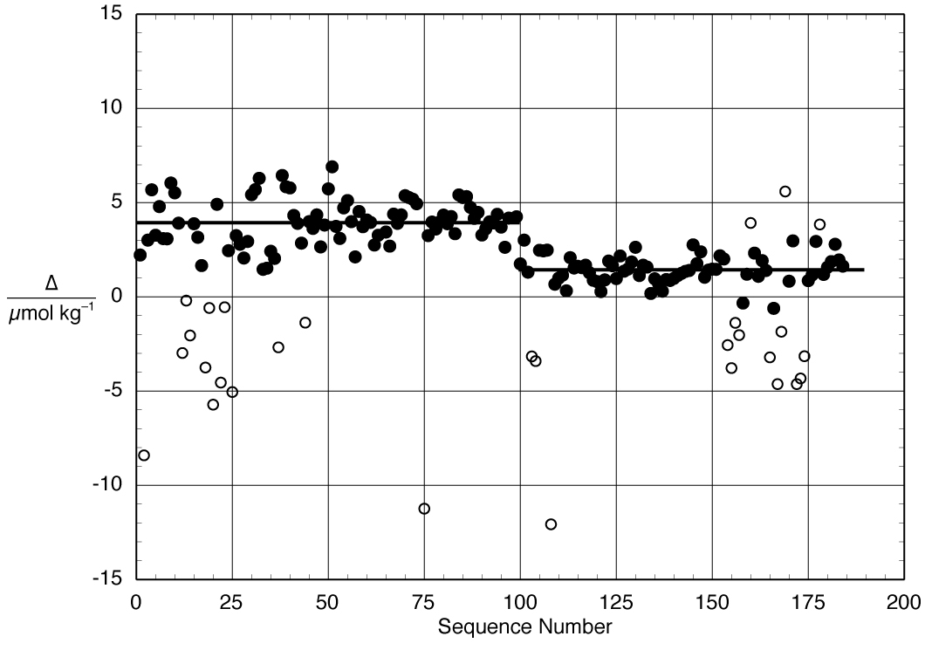
Fig. 2. Plot of the deviations of analyses of reference materials (Batch 60 and Batch 61) from the certified values (∆ = measured value – certified value). Values depicted by open circles are considered “outliers.”
An examination of Fig. 2 suggests that there was a change in the system calibration at around the 100th reference material measurement (October 7, 2003). It seems from a review of contemporaneous notes that the syringe that was being used to dispense the seawater samples for analysis was changed on that date. It also appears that there may be an error in calibrating the volume dispensed from the syringe (or perhaps in the acid concentration value).
It thus seemed appropriate to treat the data in Fig. 2 as comprising two groups: stations 1–37 and 38–88 (i.e., before and after the syringe change):

Δ_{1–37} = 3.92 ± 1.23 μmol/kg (86); Δ_{38–88} = 1.44 ± 0.74 μmol/kg (66).

A decision was thus made to also treat the cruise data as being in the same two groups, and to calibrate the reported data by adjusting the measured results so as to correct these CRM results to a ∆ of zero. The adjustment chosen was multiplicative (as would be expected if the deviation was indeed due to a poorly calibrated dispensing system). The reported data for stations 1–37 have thus been multiplied by a calibration factor of 0.99822, and those for stations 38–88 by a factor of 0.99935.
Finally, the adjusted alkalinity data results were multiplied by a factor of 1.0002 to correct for the dilution inherent in adding mercuric chloride to the sample to preserve it for analysis.
Once the at-sea alkalinity measurements had been adjusted in this fashion, they were salinity normalized to a salinity of 35 and the resulting values plotted in Ocean Data View to help identify any questionable data. As a result of this analysis, 16 points were identified as either questionable or bad, and flagged accordingly.

3.3.2 Section A22_2003
Dr. Frank Millero’s group of Rosenstiel School of Marine and Atmospheric Science (RSMAS), University of Miami, was responsible for the TALK measurements during section A22_2003. The titration systems (Fig. 3) used to determine TALK, TCO₂, and pH consisted of a Metrohm 665 Dosimat titrator and an Orion 720A pH meter that is controlled by a personal computer (Millero et al. 1993b). Both the acid titrant in a water jacketed burette and the seawater sample in a water jacketed cell were controlled to a constant temperature of 25 ± 0.1°C with a Neslab constant temperature bath. The Plexiglas water jacketed cell used is shown in Fig. 3. These cells had fill-and-drain valves that increased the reproducibility of the cell volume.
The TALK system consisted in a manifold which allows the automated measurement of eight samples. A set of pumps, valves and relays are used to rinse, fill and drain the TALK cell (Fig. 3). The titration is controlled programmatically using National Instrument’s Labwindows/CVI environment. The titration is made by adding HCl to seawater past the carbonic acid end point. A typical titration records the electro-magnetic fields (emf) reading after the readings become stable (± 0.05 mV) and adds enough acid to change the voltage to a pre-assigned increment (10 mV). In contrast to the delivery of a fixed volume increment of acid, this method gives more data points in the range of rapid increase in the emf near the endpoint. A full titration (25 points) takes about 20 min. Using two automated systems a 32-bottle station cast can be completed in 8 h.
The electrodes used to measure the emf of the sample during a titration consisted of a ROSS 8101 glass pH electrode and an Orion 90-02 double junction Ag/AgCl reference electrode.
The HCl used throughout the cruise were made, standardized, and stored in 500 cm3 glass bottles in the laboratory for use at sea. The 0.23202 M HCl solutions were made from 1 M Mallinckrodt standard solutions in 0.45 M NaCl to yield an ionic strength equivalent to that of average seawater (≈0.7 M). The acid was standardized using a coulometric technique by our group and Dickson (Taylor and Smith, 1959; Marinenko and Taylor, 1968). Both results agree to ± 0.0001 M.
The volumes of the cells used at sea were determined in the laboratory by assuming a volume of 200cm³, then running many measurements of seawater with a known TALK. Once the TALK values agree to ± 1 μmol/kg, the known TALK of the sample is used to back-calculate the volume of the cell. The volume is reproducible to ± 0.01 cm³. Measurements of the TALK of CRM throughout the cruise are used to confirm the volume on each cell.
The volume of HCl delivered to the cell is traditionally assumed to have small uncertainties (Dickson 1981) and equated to the digital output of the titrator. Calibration of the burette of the Dosimat with Milli-Q water at 25°C indicate that the system delivers 3.000 cm3 (the value for a titration of seawater) to a precision of ± 0.0004 cm3. This uncertainty results in an error of ± 0.4 μmol/kg in TALK and TCO2. The accuracy of the volume of acid delivered by the Dosimat, however, is ten times bigger than the precision. Since the titration systems are calibrated using standard solutions, this error in the accuracy of volume delivery will be partially canceled and included in the value of cell volumes assigned.
The TALK of seawater was evaluated from the proton balance at the alkalinity equivalence point, pHequiv = 4.5, according to the exact definition of TALK (Dickson 1981)
TALK = [HCO3-] + 2[CO32-] + [B(OH)4-] + [OH-] + [HPO42-] + 2[PO43-]
+ [SiO(OH)3-] - [H+] - [HSO4-] - [HF] - [H3PO4] (1)

At any point of the titration, the TALK of seawater can be calculated from the equation

(V₀ TA - VN)/(V₀ + V) = [HCO3-] + 2[CO32-] + [B(OH)4-] + [OH-]
+ [HPO42-] + 2[PO43-] + [SiO(OH)3-] - [H+] - [HSO4-] - [HF] - [H3PO4] (2)

where V₀ is the volume of the cell, N is the normality of the acid titrant, and V is the volume of acid added. In the calculation all the volumes are converted to mass using the known densities of the solutions.
A computer program has been developed in Labwindows/CVI to calculate the carbonate parameters (pHsw, E*, TALK, TCO₂, and pK1) in seawater solutions. The program is patterned after those developed by Dickson (1981), Johansson and Wedborg (1982) and DOE 1994. The fitting is performed using the STEPIT routine (J.P. Chandler, Oklahoma State University, Stillwater, OK 74074). The STEPIT software package minimizes the sum of squares of residuals by adjusting the parameters E*, TALK, TCO2 and pK1. The computer program is based on equation (2) and assumes that nutrients such as phosphate, silicate and ammonia are negligible. This assumption is valid only for surface waters. Neglecting the concentration of nutrients in the seawater sample does not affect the accuracy of TALK, but does affect the carbonate alkalinity.

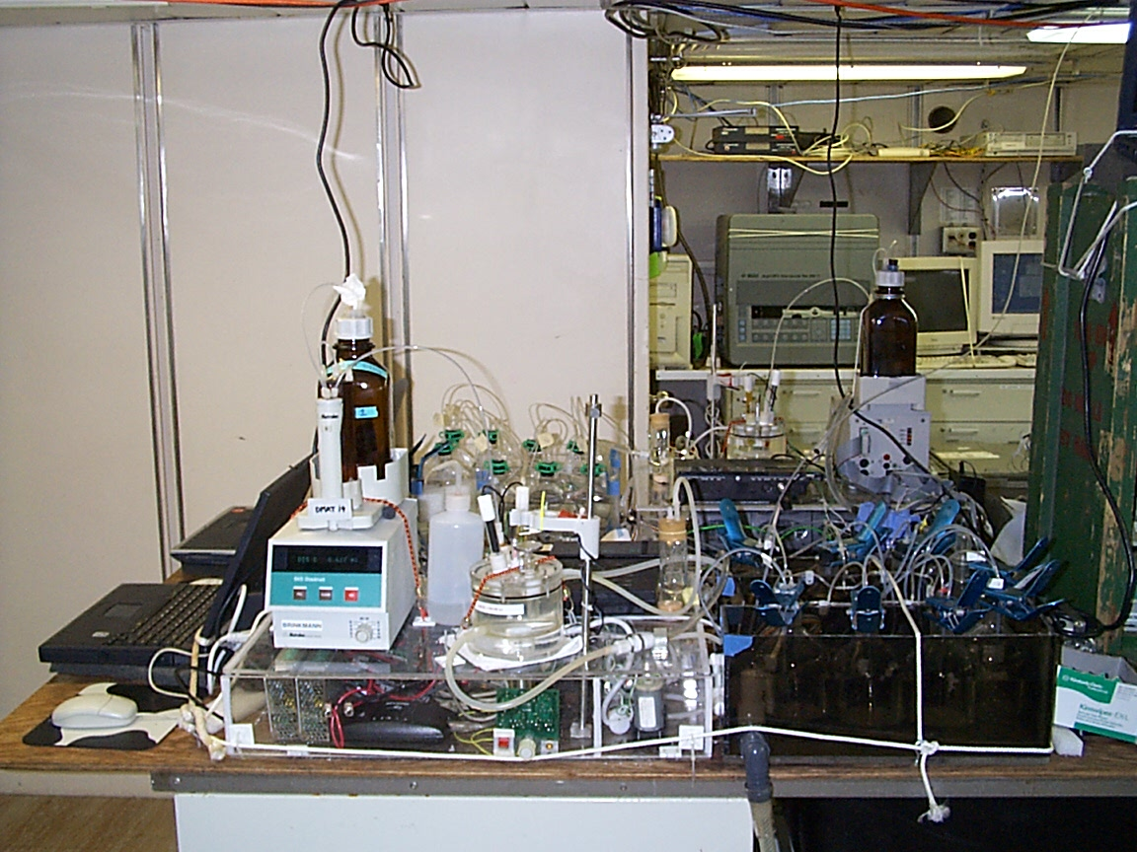

Fig. 3. Auto-titration system used during the section A22_2003 cruise.
The pH and pK of the acids used in the program are on the seawater scale, [H+]sw = [H+] + [HSO4-] + [HF] (Dickson, 1984). The dissociation constants used in the program were taken from Dickson and Millero (1987) for carbonic acid, from Dickson (1990a) for boric acid, from Dickson and Riley (1979) for HF, from Dickson (1990b) for HSO4- and from Millero (1995) for water. The program requires as input the concentration of acid, volume of the cell, salinity, temperature, measured emf (E) and volume of HCl (VHCl). To obtain a reliable TALK from a full titration at least 25 data points should be collected (9 data points between pH 3.0 to 4.5). The precision of the fit is better than 0.4 μmol/kg when pK1 is allowed to vary and 1.5 μmol/kg when pK1 is fixed. The titration program has been compared to the titration programs used by others (Johansson and Wedborg 1982, Bradshaw and Brewer 1988) and the values of TALK agree to within ± 1 μmol/kg.

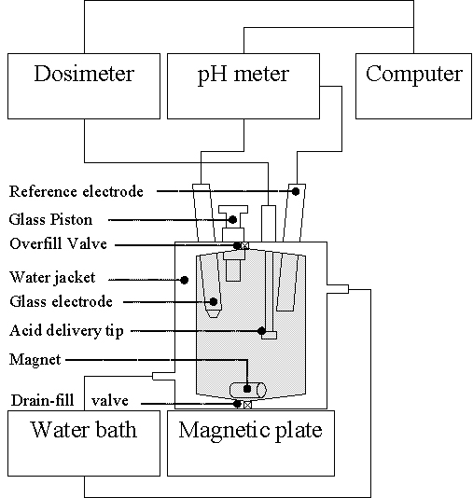

Fig. 4. Titration cell diagram.

The spectroscopic pH and potentiometric TALK of CRM used during the cruise have been measured in the laboratory before the cruise to characterize the pH of the standard and ensure the titration systems were performing to the desired precision. During the cruise, titrations on CRM were made to ensure that the two titration systems were giving consistent values. The values of pH, TCO₂, and TALK for CRM No. 61 are summarized in Table 4. The precision of the measurements was ± 3.6 µmol/kg for TALK, ± 3.4 µmol/kg for TCO₂, and ± 0.009 for pH. The average values agreed to the certified values to ± 1.8 µmol/kg in TALK, ± 4.7 µmol/kg in TCO₂, and ± 0.009 for pH. The deviations in TALK, TCO₂ and pH for all the CRMs are shown in Figs. 5–7. The deviations are within 2σ for most of the measurements. Since the average offset between the TALK measurements of CRM agreed within experimental error, no corrections were made in our field measurements of TALK. A small correction factor was made for TCO₂ (a factor of 0.9951 was multiplied to System 2) and pH (a factor of 0.004 was added to System 1 and 0.015 to System 2) to the values for each titration system. The TCO₂ measurements made on the titrations system have been compared to the values measured with the SOMMA system on the same samples. These results are shown in Fig. 8. The average differences of the adjusted values of the titration TCO₂ on all the measurements made on the cruise agree with the SOMMA values to ± 3.0 µmol/kg, which is within the precision of the measurements. These comparisons indicate that the titration values of TCO₂ from the alkalinity systems can yield reasonable values if the system is calibrated with CRM in agreement with earlier studies (Millero et al. 1993b). Note: the TCO₂ and pH values that have been measured on the alkalinity system are not present in the dataset for section A22_2003.

Table 4. Summary of certified reference material measurements
 | TA µmol/kg | TCO₂ µmol/kg | pH @ 25ºC | Total runs
Leg 1
System 1 | 2203.4 ± 2.8 | 1999.4 ± 3.5 | 7.887 ± 0.008 | 43
System 2 | 2204.2 ± 4.4 | 2008.1 ± 3.4 | 7.876 ± 0.010 | 47
Combined | 2203.8 ± 3.6 | 2003.9 ± 3.4 | 7.881 ± 0.009 | 90
Certified Values
CRM Batch 61 | 2202.04 | 1998.2 | 7.891

Fig. 5. Deviation between the TALK and CRM for both systems.

Fig. 6. Deviation between the TCO₂ and CRM for both systems.

Fig. 7. Deviation between the pH and CRM for both systems.

Fig. 8. Difference between the TCO₂ of the SOMMA and TALK system results.

The precision of the instruments was also tested by making duplicate measurements of samples throughout the cruise. These duplicates were taken from the same niskin bottle, equilibrated for an equal amount of time, and then measured on the same instrument. A total of 117 duplicate samples was made, and the results showed that the average delta was 0.2 ± 1.8 μmol/kg for TALK, 0.2 ± 1.3 μmol/kg for TCO₂, and 0.000 ± 0.003 for pH. Table 5 and Figs. 9–11 summarize these results.

Table 5. Summary of duplicate measurements
 | TALK µmol/kg | TCO₂  µmol/kg | pH | Total runs
System 1 | 0.0 ± 1.1 | 0.3 ± 1.5 | 0.000 ± 0.003 | 62
System 2 | 0.5 ± 2.6 | 0.1 ± 1.1 | 0.000 ± 0.003 | 55
Combined | 0.2 ± 1.8 | 0.2 ± 1.3 | 0.000 ± 0.003 | 117

Fig. 9. Deviation of TALK on duplicate samples.

Fig. 10. Deviation of TCO₂ on duplicate samples.

Fig. 11. Deviation of pH on duplicate samples.

The carbonate system is characterized by four parameters: TALK, TCO₂, partial pressure of carbon dioxide (pCO₂), and pH. Knowing two of these parameters, one can calculate the other two. If more than two parameters are known, a comparison of calculated and measured values will tell if the measured value is internally consistent with the two used in the calculation. We have examined the internal consistency of pH and TALK measurements and the SOMMA values of TCO₂. The “CO₂sys.bas” basic program used to make these calculations was written by Lewis and Wallace (1998) and modified by Denis Pierrot to run in Excel. We used the carbonic acid constants of Mehrbach (1973) and refit by Dickson and Millero (1987) for all calculations, as well as the constant of Dickson (1990b) for bisulfate all on the seawater pH scale. We examined an input of pH and TALK to calculate TCO₂, pH and TCO₂ to calculate TALK, and TALK and TCO₂ to calculate pH. The results of these calculations are summarized in Table 6 and the deviations are shown in Figs. 12–14.

Table 6. Summary of internal consistency deviations
Input | pH and TCO₂ | TALK and TCO₂ | pH and TALK | SOMMA - Titrator
Output | ∆ TALK | ∆ pH | ∆ TCO₂ | ∆ TCO₂
 | 1.1 ± 3.9 | 0.002 ± 0.008 | 1.1 ± 3.7 | 2.6 ± 3.0
Runs | 1375 | 1375 | 1375 | 1394

Fig. 12. Difference in calculated and measured TALK using an input of pH and TCO₂.

Fig. 13. Difference in calculated and measured TCO₂ using an input of TALK and pH.

Fig. 14. Difference in calculated and measured pH using an input of TALK and TCO₂.

Once the data have been proven accurate and precise, as well as internally consistent, a comparison of the 1997 and 2003 cruises were made.
In looking at the changes in the carbonate system of the ocean, the surface measurements are of the greatest concern. These values change much more than do the deep water values. The following figures are a comparison between the 1997 and 2003 cruises along section A22 showing a variety of measurements versus latitude. Fig. 15 details the salinity measurements that were obtained from the ship’s CTD measurements. The overall trend of salinity seems to remain fairly consistent. Fig. 16 shows the values for temperature, which were also obtained from the ship’s CTD measurements. The overall trend for the temperature is slightly askew because the 1997 cruise took place in late summer and the 2003 cruise took place in the fall. Fig. 17 compares the normalized TALK of the two cruises (normalized TALK meaning corrected to a salinity of 35, or NTA = TA × 35/S, see Millero 1996). The overall trend of NTA remains fairly consistent between the two cruises. Fig. 18 shows the normalized TCO₂ (normalized meaning corrected to a salinity of 35, or NTCO₂ = TCO₂ × 35/S, see Millero 1996). The trend has remained consistent, but the concentration of TCO₂ has increased due to the uptake of anthropogenic carbon dioxide from industrialized countries. This effect is more predominant in colder or northern waters as these waters are able to hold more dissolved gases. Figures 19 and 20 show the in situ pH and in situ pCO₂ of the two cruises, respectively. These values were calculated from the temperatures and pressures at which the samples were taken, with pCO₂ being calculated from the TALK and TCO₂. The figures are basically inverses of one another, because carbon dioxide acts as a weak acid; therefore, as the concentration of pCO₂ increases, the pH decreases and vice versa.

Fig. 15. Surface measurements of salinity versus latitude from the 1997 and 2003 cruises.

Fig. 16. Surface measurements of temperature versus latitude from the 1997 and 2003 cruises.

Fig. 17. Surface measurements of NTA versus latitude from the 1997 and 2003 cruises.

Fig. 18. Surface measurements of NTCO₂ versus latitude from the 1997 and 2003 cruises.

Fig. 19. Surface measurements of in situ pH versus latitude from the 1997 and 2003 cruises.

Fig. 20. Surface measurements of in situ pCO₂ versus latitude from the 1997 and 2003 cruises.
After reviewing the accuracy, precision and internal consistency of the data, we feel very confident in the level of quality of these data. In comparison with the 1997 cruise, it is very clear that the anthropogenic output of CO₂ has been increasing in the atmosphere, and in turn, has increased the concentration of TCO₂ and pCO₂ in the surface of the ocean. This effect is more pronounced in northern latitudes where there is colder water, but the increase is also noticeable in the equatorial regions. The increase in CO₂ has caused a slight decrease in the pH, because CO₂ acts as a weak acid, effectively lowering the pH. However, there were no significant findings in increase or decrease of the TALK. Such changes in the oceans need to be constantly monitored to better understand and predict what may happen due to human activity on earth.

3.4 Dissolved Organic Carbon Measurements
All samples were collected directly from the Niskin Bottles. Because particulate organic carbon concentrations in the surface waters can be elevated all samples collected from the upper 500 m were filtered. Water was filtered through a combusted GF/F housed in an acid washed polycarbonate filter cartridge attached directly the Niskin bottle spigot. All samples were collected directly into an acid washed and Nanopure flushed high density polyethylene (HDPE) bottles (60ml). Samples were immediately placed upright in a -20°C freezer and samples were shipped to shore laboratory packed in dry ice. All samples were kept frozen at -20°C in an organic (volatile) free environment.
All DOC samples were analyzed via high temperature combustion using Shimadzu TOC-V in shore based laboratory at the University of California, Santa Barbara. The operating conditions of the Shimadzu TOC-V were slightly modified from the manufacturer’s model system. The condensation coil was removed and the head space of an internal water trap was reduced to minimize the system’s dead space. The combustion tube contained 0.5 cm Pt pillows placed on top of Pt alumina beads to improve peak shape and to reduce alteration of combustion matrix throughout the run. CO₂ free carrier gas was produced with a Whatman® gas generator (Carlson et al. 2004). Samples were drawn into 5 mL injection syringe and acidified with 2M HCl (1.5%) and spared for 1.5 min with CO₂ free gas. Three to five replicate 100 µL of sample were injected into combustion tube heated to 680° C. The resulting gas stream was passed though a several water and halide traps, the CO₂ in the carrier gas was analyzed with a non-dispersive infrared detector and the resulting peak area was integrated with Shimadzu chromatographic software. Injections continued until the at least three injection meet the system specified range of a SD of 0.1 area counts, CV ≤2% or best 3 of 5 injections.
Extensive conditioning of the combustion tube with repeated injections of low-carbon water and deep seawater was essential to minimize the machine blanks. After conditioning, the system blank was assessed with ultra-violet oxidized low carbon water. The system response was standardized with a four-point calibration curve of potassium hydrogen phthalate solution in low-carbon water. All samples were systematically referenced against low-carbon water, deep Sargasso Sea reference waters (2600 m) and surface Sargasso Sea water every 6–8 analyses (Hansell and Carlson 1998). The standard deviation of the deep and surface references analyzed throughout a run generally have a coefficient of variation ranging between 1–3% over the 3–7 independent analyses (number of references depends on size of the run) (see Hansell 2005). Daily reference waters were calibrated with DOC CRM provided by D. Hansell (University of Miami). The UCSB DOC laboratory exchanges references and samples with the Hansell DOC laboratory to ensure similar performance of DOC systems and comparability of data.
DOC calculation:
µMC = (average sample area – average machine blank area) / (slope of std curve)

3.5 Total Dissolved Nitrogen Measurements
Total dissolved nitrogen samples were analyzed via high temperature combustion using a Shimadzu TOC-V with attached Shimadzu TNM1 unit at an in-shore based laboratory at the University of California, Santa Barbara. The operating conditions of the Shimadzu TOC-V were slightly modified from the manufacturer’s model system. The condensation coil was removed and the headspace of an internal water trap was reduced to minimize the system’s dead space. The combustion tube contained 0.5 cm Pt pillows placed on top of Pt alumina beads to improve peak shape and to reduce alteration of combustion matrix throughout the run. Carrier gas was produced with a Whatman® gas generator (Carlson et al. 2004) and ozone was generated by the TNM1 unit at 0.5 L/min flow rate. Three to five replicate 100 µL of sample were injected at 130 mL/min flow rate into the combustion tube heated to 680° C, where the total dissolved nitrogen in the sample was converted to nitric oxide (NO). The resulting gas stream was passed through an electronic dehumidifier. The dried NO gas then reacted with ozone producing an excited chemiluminescence NO₂ species (Walsh 1989) and the fluorescence signal was detected with a Shimadzu TNMI chemiluminescence detector. The resulting peak area was integrated with Shimadzu chromatographic software. Injections continued until at least three injections meet the specified range of a SD of 0.1 area counts, CV ≤2% or best 3 of 5 injections.
Extensive conditioning of the combustion tube with repeated injections of low nitrogen water and deep seawater was essential to minimize the machine blanks. After conditioning, the system blank was assessed with ultra-violet oxidized low nitrogen water. The system response was standardized daily with a four-point calibration curve of potassium nitrate solution in blank water. All samples were systematically referenced against low nitrogen water and deep Sargasso Sea reference waters (2600 m) and surface Sargasso Sea water every 6–8 analyses (Hansell and Carlson 1998). Daily reference waters were calibrated with deep CRM provided by D. Hansell (University of Miami; Hansell 2005).
Total dissolved nitrogen calculation:
µMN = (average sample area – average machine blank area) / (slope of std curve)

3.6 Chlorofluorocarbon Measurements

3.6.1 Sample Collection
All samples were collected from depth using 10-L Niskin bottles. None of the Niskin bottles used showed a CFC contamination throughout the cruise. All bottles in use remained inside the CTD hanger between casts.
Both the Lamont-Doherty Earth Observatory and RSMAS analytical instruments were on board so each group sampled and analyzed every other station. Each system was capable of analyzing CFC-11, CFC-12, and CFC-113. The RSMAS system was also capable of analyzing CCl₄. CFC sampling was conducted first at each station, according to WOCE protocol. This avoids contamination by air introduced at the top of the Niskin bottle as water was being removed. A water sample was collected directly from the Niskin bottle petcock using a 100 mL ground glass syringe which was fitted with a three-way stopcock that allowed flushing without removing the syringe from the petcock. Syringes were flushed several times and great care was taken to avoid contamination by air bubbles. Two duplicate samples were taken on most stations from random Niskin bottles, one duplicate was for same analytical system analysis, to calculate precision and the other was for cross analytical system comparison. Air samples, pumped into the system using an Air Cadet pump from a Dekoron air intake hose mounted high on the foremast were run when time permitted.

3.6.2 RSMAS Equipment and Technique
The RSMAS system analyzed 46 complete stations out of 88 for a total of 1357 samples on A20, and 42 complete stations out of 82 for a total of 1298 samples on A22. Halocarbon analyses were performed on a gas chromatograph (GC) equipped with an electron capture detector. Samples were introduced into the GC-EDC via a purge and dual trap system. The samples were purged with nitrogen and the compounds of interest were trapped on a main Porapack N trap held at ~ -15ºC with a Vortec Tube cooler. After the sample had been purged and trapped for several minutes at high flow, the gas stream was stripped of any water vapor via a magnesium perchlorate trap prior to transfer to the main trap. The main trap was isolated and heated by direct resistance to 140ºC. The desorbed contents of the main trap were back-flushed and transferred, with helium gas, over a short period of time, to a small volume focus trap in order to improve chromatographic peak shape. The focus trap was also Porapak N and is held at ~ −15 ºC with a Vortec Tube cooler. The focus trap was flash heated by direct resistance to 155 ºC to release the compounds of interest onto the analytical pre-column. The pre-column was the first 5 meters of a 60 m Gaspro capillary column with the main column consisting of the remaining 55 meters. The analytical pre-column was held in-line with the main analytical column for the first 2 min of the chromatographic run. After 2 min, all of the compounds of interest were on the main column and the pre-column was switched out of line and back-flushed with a relatively high flow of nitrogen gas. This prevented later eluting compounds from building up on the analytical column, eventually eluting and causing the detector baseline signal to increase.
The syringes were stored in a flow-through seawater bath and analyzed within 8–12 h after collection. Bath temperature was recorded every time a sample was analyzed for use in calculating the mass of water analyzed. Every 12 to 18 measurements were followed by a purge blank and a standard. The surface sample was held after the initial measurement and was sent through the process again in order to “restrip” it to determine the efficiency of the purging process.

3.6.3 Lamont-Doherty Earth Observatory Equipment and Technique
Water was transferred from the syringe into a purge and trap system interfaced to a Hewlett Packard 5890 gas chromatograph with an electron capture detector. The gas chromatography was carried out using a 40 inch x 1/8 inch diameter pre-column of porasil B, a 60 in. × 1/8 in. diameter main column of carbograph-1AC and a 4 in. × 1/8 in. diameter post column of molecular sieve 5A. The molecular sieve 5A column separated CFC-12 from nitrous oxide and was valved out of the gas stream before CFC-11 eluted from the main column. The combination of the pre-column and main column provided excellent separation of CFCs 11, 12, and 113 as well as separation of CFC-113 from methyl iodide. The gas chromatograph was calibrated against a known gas standard and concentrations are reported on the SIO98 scale. The precision of this technique was the larger of 1% or 0.01 pmol/kg.

3.6.4 Calibration
A gas phase standard, ALM35078, was used for calibration. The concentrations of the CFCs in this standard are reported on the SIO 1998 absolute calibration scale. Multiple calibration curves were run over the course of the cruise on each analytical system. Estimated accuracy is ± 2%. Precision for CFC-12, CFC-11, CFC-113 and CCl₄ was less than 1%. Estimated limit of detection is 0.010 pM/kg for CFC-12 and CFC-113, and 0.005 pM/kg for CFC-11 and CCl₄.
3.6.5 Technical Problems
In large part, sample collection and measurement were very successful. The integration of the computer software with the GC-EDC system hardware made the procedure almost completely automated. There were no incidents that caused significant instrument down time.

3.6.6 Processing of External Duplicates
External duplicates are defined as samples where RSMAS and Lamont both sampled the same station/bottle. The Lamont and Miami systems were compared throughout the A20 and A22 legs by running duplicate samples from stations on both systems.
For A20 the agreement between these duplicates was within the measurement error for CFC-11 and CFC-12. For CFC-11 and CFC-12 external duplicates, the CFC values were averaged if both RSMAS and Lamont samples had QB=2. If one of the lab’s samples had a questionable (QB=3) or bad (QB=4) quality designation, then the other lab’s sample was used for that CFC value for that particular station/bottle.
For A22 the Lamont CFC-11 and CFC-12 data were higher than the Miami data and were believed to be in error because the surface waters measured by the Lamont system were consistently supersaturated by about 10% and the Miami data were close to 100% saturation. A correction was applied to the Lamont data to bring it in line with the Miami data. All of the Lamont data for A22 was reduced by 5.5% and a further correction was applied to stations 38-82 to correct for a small leak that apparently developed in the Lamont system for these stations. Comparison of the duplicates run on the Lamont and Miami systems after the corrections yielded an error of the larger of 0.01 pmol kg⁻¹ or 1.7 % for CFC-11 and CFC-12 and 0.01 pmol/kg for CFC-113.
Following the offset correction made by Lamont on their data, the CFC-11 and CFC-12 external duplicates (with QB=2) were compared to determine whether they were within 5% of each other. If the RSMAS and Lamont values were within 5% of each other, they were averaged. If they were not, then the value that most closely fit with the remainder of the station and surrounding stations was chosen. This was determined by examining plots of CFCs and Pressure.
For CFC113, there was a ~10% difference between the RSMAS and Lamont values. The external duplicates were not averaged. The CFC113 sample from the lab that sampled the remainder of the station was used instead.
RSMAS sampled CCl₄. Lamont did not analyze water samples for CCl₄.

3.7 ¹⁴C and ¹³C Measurements
A small number of samples (34 surface and 3 depth profiles) were collected directly from the Niskin bottles for measurement of radiocarbon in dissolved inorganic ¹⁴C using the procedures described at http://nosams.whoi.edu/clients/submissions_sample_prep.html#dic. Samples were poisoned with mercuric chloride and shipped to National Ocean Sciences Accelerator Mass Spectrometry Facility (NOSAMS) for analysis. For radiocarbon analyses, the procedures used are described in McNichol et al. (1994), McNichol and Jones in WHP 91-1 (accessible at http://whpo.ucsd.edu/manuals.htm), and McNichol et al. 2000, 2001. Briefly, the carbon is first extracted in a sample as CO₂ and then reduced from a gas to solid carbon. Samples are acidified with phosphoric acid and CO₂ gas is stripped out with a nitrogen carrier gas. After conversion to CO₂, samples are reduced to “graphite” on Fe powder with hydrogen gas as the reducing agent. Sample graphite compacted into target cartridges is loaded into a multi-sample wheel mounted in the accelerator mass spectrometry (AMS) Cs-sputter ion source. The graphite (pure carbon) derived from a sample is compressed by the target press and inserted into the cathode of the AMS ion source where the ratio of ¹⁴C to ¹²C is measured and compared to that of known standards. Shipboard duplicates, i.e., two separate AMS samples collected from the same water depth but measured separately, continue to show a high level of precision (Elder et al. 1998). Fifteen paired analyses from samples collected along 150°W in the North Pacific demonstrate reproducibility of ± 3.3% for dissolved inorganic ¹⁴C and ± 0.04% for dissolved inorganic ¹³C, consistent with results we have obtained in the past. This precision is obtained through careful preparation in the laboratory, increased counting statistics on the accelerator, and careful quality screening after analysis. Long-term reproducibility of results over time is demonstrated by periodically re-running entire water profiles from randomly selected stations.
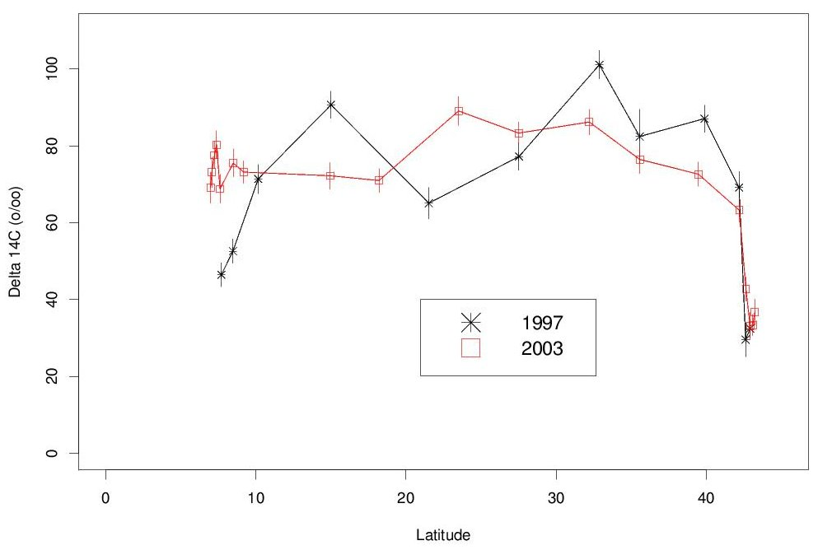

Fig. 21. Surface measurements of ¹⁴C versus longitude from the 1997 and 2003 cruises (A20).

Comparing the surface values obtained in 1997 with those measured here (Figs. 21 and 22 below for ¹⁴C and Figs. 23 and 24 for ¹³C) shows no obvious patterns of change. There is a hint of an increase near the equator, but the sparse data set makes it challenging to consider this a robust feature.

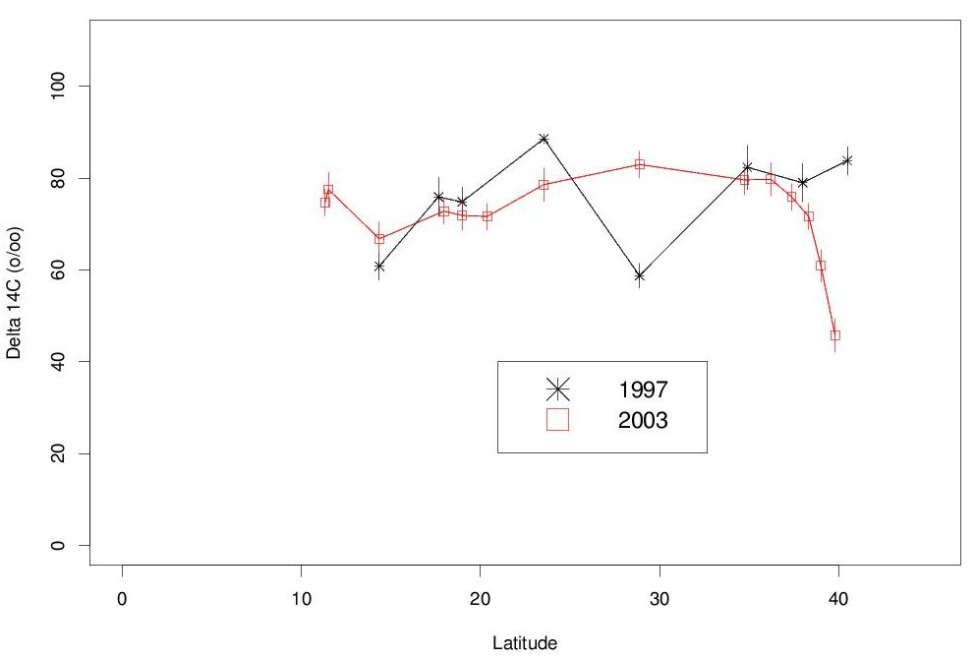

Fig. 22. Surface measurements of ¹⁴C versus longitude from the 1997 and 2003 cruises (A22).
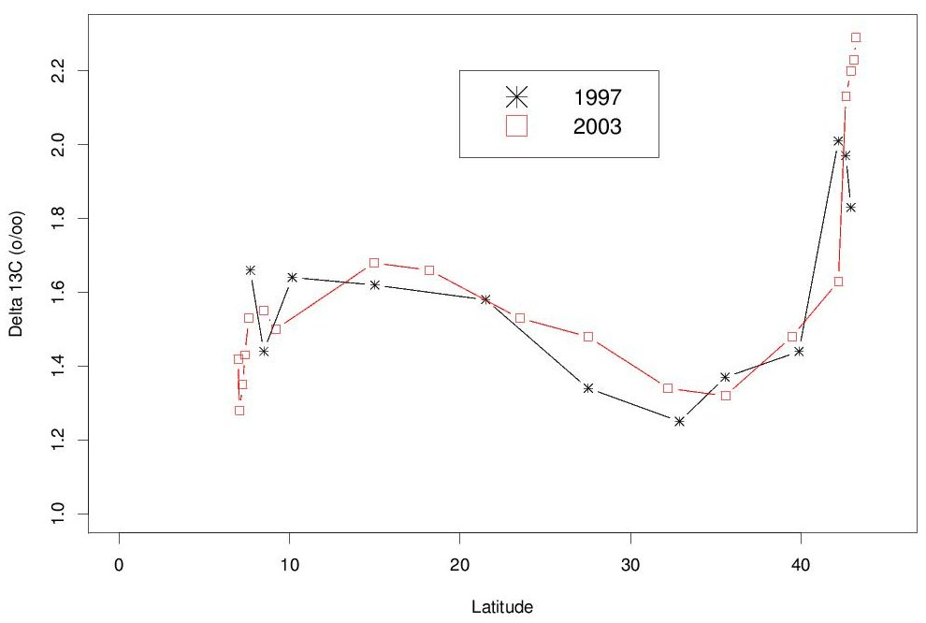

Fig. 23. Surface measurements of ¹³C versus longitude from the 1997 and 2003 cruises (A20).

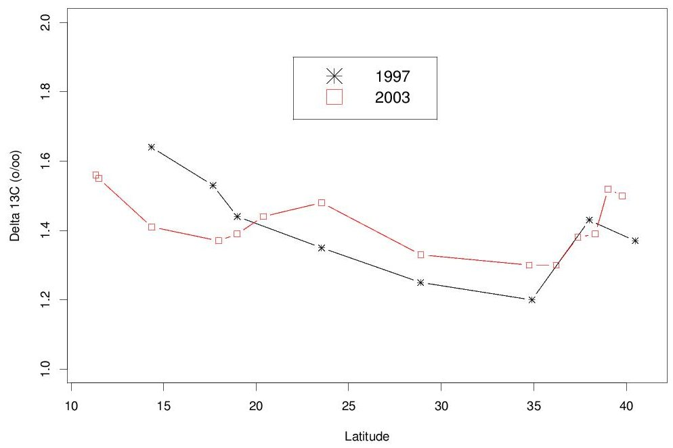
Fig. 24. Surface measurements of ¹³C versus longitude from the 1997 and 2003 cruises (A22).

4. HOW TO OBTAIN THE DATA AND DOCUMENTATION
This database (NDP-089) is available free of charge from CDIAC. The complete documentation and data can be obtained from the CDIAC oceanographic web site (http://cdiac.ornl.gov/oceans/doc.html), through CDIAC’s online ordering system (http://cdiac.ornl.gov/pns/how_order.html) or by contacting CDIAC.
The data are also available from CDIAC’s anonymous file transfer protocol (FTP) area via the Internet. (Please note that your computer needs to have FTP software loaded on it. It is included in most newer operating systems.) Use the following commands to obtain the database:

ftp cdiac.ornl.gov or >ftp 160.91.18.18
Login: “anonymous” or “ftp”
Password: your e-mail address
ftp> cd pub/ndp089/
ftp> dir
ftp> mget (files)
ftp> quit

The full datasets from the cruise, including bottle and CTD data, can be found at the CLIVAR repeat hydrography website: http://ushydro.ucsd.edu/cruise_data_links.html.

Contact information:

Carbon Dioxide Information Analysis Center
Oak Ridge National Laboratory
P.O. Box 2008
Oak Ridge, Tennessee 37831-6335
USA

Telephone: (865) 574-3645
Telefax: (865) 574-2232

E-mail: cdiac@ornl.gov
Internet: http://cdiac.ornl.gov/

REFERENCES
Armstrong, F.A.J., C.R. Stearns, and J.D.H. Strickland. 1967. “The measurement of upwelling and subsequent biological processes by means of the Technicon AutoAnalyzer and associated equipment.” Deep-Sea Research 14:381–89.
Bradshaw, A. L., and P. G. Brewer. 1988. “High-precision measurements of alkalinity and total carbon dioxide in seawater by potentiometric titration-1: Presence of unknown protolyte(s)?” Maine Chemistry 23:69–86.
Carlson, C.A., et al. 2004. “Interactions between DOC, microbial processes, and community structure in the mesopelagic zone of the northwestern Sargasso Sea.” Limnology and Oceanography 49:1073–1083.
Carpenter, J. H. 1965. “The Chesapeake Bay Institute technique for the Winkler dissolved oxygen method.” Limnology and Oceanography 10:141–43.
Culberson, C. H., G. Knapp, M. Stalcup, R. T. Williams, and F. Zemlyak. 1991. A Comparison of Methods for the Determination of Dissolved Oxygen in Seawater. WHP Office Report, WHPO 91-2. WOCE Hydrographic Program Office, Woods Hole, Mass.
Dickson, A. G. 1981. “An exact definition of total alkalinity and a procedure for the estimation of alkalinity and total CO₂ from titration data.” Deep-Sea Research 28:609–23.
Dickson, A.G. 1984. “pH scales and proton-transfer reactions in saline media such as seawater,” Geochim. Cosmochim. Acta, 48, 2299–2308.
Dickson, A.G. 1990a. “Thermodynamics of the dissociation of boric acid in synthetic seawater from 273.15 to 318.15 K.” Deep-Sea Research Part A, 37/5:755–66.
Dickson, A.G. 1990b. Standard potential of the (AgCl + 1/2 H2= Ag + HCl(aq)) cell and the association of bisulfate ion in synthetic sea water from 273.15 to 318.15 K, J. Chem. Thermody., 22, 113– 127.
Dickson, A.G., and F.J. Millero. 1987. “A comparison of the equilibrium constants for the dissociation of carbonic acid in seawater media.” Deep-Sea Research Part A, 34/10:1733–43.
Dickson, A.G., and J.P. Riley. 1979. “The estimation of acid dissociation constants in seawater media from potentiometric titration with strong base, 1: The ionic product of water-KSUS-w.” Marine Chemistry 7/2:89–99.
Dickson, A. G., J. D. Afghan, and G. C. Anderson. 2003. Reference materials for oceanic CO₂ analysis: A method for the certification of total alkalinity. Marine Chemistry 80:185–197.
DOE (U.S. Department of Energy). 1994. Handbook of Methods for the Analysis of the Various Parameters of the Carbon Dioxide System in Seawater. Version 2.0. ORNL/CDIAC-74. Ed. A. G. Dickson and C. Goyet. Carbon Dioxide Information Analysis Center, Oak Ridge National Laboratory, Oak Ridge, Tenn.
Elder, K. L., A. McNichol, et al. (1998). "Reproducibility of seawater, inorganic and organic carbon C-14 results at NOSAMS." Radiocarbon 40(1): 223–230.
Friederich, G. E., P. Sherman, and L. A. Codispoti. 1984. A High-Precision Automated Winkler Titration System Based on a HP-85 Computer, A Simple Colorimeter and an Inexpensive Electromechanical Buret. Bigelow Laboratory Technical Report, 42. Bigelow Laboratory for Ocean Sciences, West Boothbay Harbor, Maine.
Gordon, L.I., et al. 1992. A suggested protocol for continuous automated analysis of seawater nutrients (phosphate, nitrate, nitrite, and silicic acid) in the WOCE Hydrographic Program and the Joint Global Ocean Fluxes Study. WOCE Operations Manual, Vol. 3: The Observational Programme, Section 3.2: WOCE Hydrographic Programme, Part 3.1.3: WHP Operations and Methods. WHP Office Report WHPO 91-1; WOCE Report No. 68/91. November 1994, Revision 1, Woods Hole, Mass., USA, 52 pp.
Hansell, D.A. and C.A. Carlson, 1998. “Deep ocean gradients in the concentration of dissolved organic carbon.” Nature, 395: 263–266.
Hansell, D.A. 2005. “Dissolved Organic Carbon Reference Material Program.” EOS, 35:318-319.
Johansson, O. and Wedborg, M., 1982. “On the evaluation of potentiometric titrations of seawater with hydrochloric acid,” Oceanol. Acta, 5, 209–218.
Johnson, K. M. 1992. Operator’s Manual: Single-Operator Multiparameter Metabolic Analyzer (SOMMA) for Total Carbon Dioxide (CT) with Coulometric Detection. Brookhaven National Laboratory, Brookhaven, N.Y.
Johnson, K. M., A. E. King, and J. M. Sieburth. 1985. “Coulometric TCO₂ analyses for marine studies: An introduction.” Marine Chemistry 16:61–82.
Johnson, K. M., et al. 1999. “Coulometric total carbon dioxide analysis for marine studies: Measurement and internal consistency of underway surface TCO₂ concentrations.” Marine Chemistry 67:123–44.
Johnson, K.M., et al. 1987. “Coulometric total carbon analysis for marine studies: Automation and calibration.” Marine Chemistry 21:117–33.
Johnson, K. M., et al. 1993. “Coulometric total carbon dioxide analysis for marine studies: Maximizing the performance of an automated gas extraction system and coulometric detector.” Marine Chemistry 44:167–87.
Lewis, E., and D.W.R. Wallace. 1998. Program developed for CO₂ system calculations. ORNL/CDIAC-105. Carbon Dioxide Information Analysis Center, Oak Ridge National Laboratory, U.S. Department of Energy, Oak Ridge, Tennessee.
Marinenko, G., and J.K. Taylor. 1968. “Electrochemical equivalents of benzoic and oxalic acid.” Analytical Chemistry 40:1645–51.
McNichol, A. P., G. A. Jones, et al. (1994). "The rapid preparation of seawater ΣCO2 for radiocarbon analysis at the National Ocean Sciences AMS Facility." Radiocarbon 36(2): 237–246.
McNichol, A. P., A. J. T. Jull, et al. (2001). "Converting AMS data to radiocarbon values: Considerations and conventions." Radiocarbon 43(2A): 313–320.
McNichol, A. P., R. J. Schneider, et al. (2000). "Ten years after - The WOCE AMS radiocarbon program." Nuclear Instruments & Methods in Physics Research Section B-Beam Interactions with Materials and Atoms 172: 479–484.
Mehrbach, C., et al. 1973. “Measurement of the apparent dissociation constants of carbonic acid in seawater at atmospheric pressure.” Limnology and Oceanography 18:897–907
Millero, F.J. 1995. “Thermodynamics of the carbon dioxide system in the oceans.” Geochim. Cosmochim. Acta., 59 (4): 661–677.
Millero, F.J. 1996. Chemical Oceanography. Boca Raton: CRC Press.
Millero, F. J., et al. 1998. “Assessment of the quality of the shipboard measurements of total alkalinity on the WOCE Hydrographic Program Indian Ocean CO₂ survey cruises, 1994–1996.” Marine Chemistry 63:9–20.
Millero, F.J., et al. 1993a. “The internal consistency of CO₂ measurements in the equatorial Pacific.” Marine Chemistry 44:269–80.
Millero, F. J., et al. 1993b. “Titration alkalinity of seawater.” Marine Chemistry 44:153–65.
PICES. 2007. Dickson, A.G., Sabine, C.L. and Christian, J.R. (Eds.). Guide to best practices for ocean CO₂ measurements. PICES Special Publication 3, 191 pp.
Taylor, J.K., and S.W. Smith. 1959. “Precise coulometric titration of acids and bases.” Journal Research of National Bureau of Standards 63:153–59.Walsh, T.W., 1989. “Total dissolved nitrogen in seawater: a new high-temperature combustion method and a comparison with photo-oxidation.” Mar. Chem., 26:295–311.

