Measurements of the partial pressure of CO₂ in near-surface seawater and in marine boundary air
(01 May 2008)

Contributors:
Hisayuki Yoshikawa Inoue* and Masao Ishii
Geochemical Research Department, Meteorological Research Institute,
1-1 Nagamine, Tsukuba, Ibaraki 305-0052, Japan

*Current address:
Laboratory of Marine and Atmospheric Geochemistry,
Graduate School of Environmental Earth Science, Hokkaido University
N10W5, Kita-ku, Sapporo 060-0810, Japan

Ships:
Measurements have been made on onboard the following ships:
RV Hakuho Maru I and II, Ocean Research Institute, the University of Tokyo
RV Ryofu Maru II, Japan Meteorological Agency
RV Natsushima, Japan Marine Science and Technology Center
RV Kaiyo Maru, Japan Fisheries Agency
MS Wellington Maru, Mitsui O.S.K. Lines
RV Sogen Maru, Marine Biotechnology Institute
TS Hokuto Maru, National Institute of Sea Training
TS Taisei Maru, National Institute of Sea Training
RV Kaiyo, Japan Marine Science and Technology Center
RV Mirai, Japan Marine Science and Technology Center
(see cruise list)

Variables:
Variable_Name: mixing ratio of CO₂ in dry air (xCO₂)
Description_of_Variable: xCO₂ in marine boundary air (xCO₂_Air) and xCO₂ in air equilibrated with near-surface seawater (xCO₂_Sea).

Equilibrator_Design:
Equilibrator_Type: shower-head
Equilibrator_Volume: 1.5 dm³
Water_Flow_Rate: ca. 6 – 10 dm³ min⁻¹
Headspace_Gas_Flow_Rate: ca.500 – 700 cm³ min⁻¹
Vented: Yes.

Calibration_Gas:
Four cylinders of reference gases have been used to calibrate the output voltage of NDIR every 60 or 90 minutes. All reference gases used onboard underwent a pre- and post-cruise calibration against MRI-87 CO₂ concentration scale of which primary standards consists of a series of primary standard gases made at Nippon Sanso Co. with a gravimetric method following the procedure reported by [Tanaka, M., T. Nakazawa and S. Aoki (1987): Time and space variations of tropospheric carbon dioxide over Japan. Tellus, 39B, 3-12.]. The difference in CO₂ concentration scale between WMO mole-fraction and MRI87 has tentatively been determined as Eq.(1):
(xCO₂^{WMO} – xCO₂^{MRI87}) / ppm
= -0.015 – 0.569 · (xCO₂^{MRI87}–370) · 10⁻² + 0.237 · (xCO₂^{MRI87}–370)² · 10⁻⁴
+ 0.341· (xCO₂^{MRI87}–370)³ · 10⁻⁶ (271 < xCO₂^{MRI87} / ppm < 405)

CO₂_Sensor: Non-Dispersive Infrared (NDIR) Gas Analyzer
Model: Beckman315A, 864, 865, 880, Rosemount Binos 4.1, LI-COR6251
Environmental_Control: Temperature controlled within the instrument around the cell of the NDIR.
CO₂_Sensor_Calibration: Once per hour or once per 1.5 hours using four standard gases.

Warming_correction:
Correction of pCO₂w in the equilibrator to the in situ pCO₂sw for seawater warming (typically 0.0< Δt/ºC <1.0 depending on the ship and location) was made using the equation given by [Gordon and Jones (1973): The effect of temperature on carbon dioxide partial pressure in seawater. Marine Chemistry, 1, 317 – 322, 1973] or [Copin-Montegut, C. (1988): A New formula for the effect of temperature on the partial pressure of CO₂ in seawater. Marine Chemistry, 25, 29–37, and Copin-Montegut, C. (1989): A new formula for the effect of temperature on the partial pressure of CO₂ in seawater. Corrigendum. Marine Chemistry, 27, 143 - 144.] after mid-1990s.

Method_References:
Inoue, H.Y., CO₂ exchange between the atmosphere and the ocean: carbon cycle studies of the Meteorological Research Institute since 1968, In: Dynamics and Characterization of Marine Organic Matter., Eds. N. Handa, E. Tanoue and T. Hama., TERAPUB/Kluwer, Tokyo, 509-53, 2000.
See also the references in the cruise list.
For at-sea intercomparison exercise, see Körtzinger, A., Mintrop, L., Duinker, J. C., The international intercomparison exercise of underway fCO₂ systems during the R/V Meteor cruise 36/1 in the North Atlantic Ocean. Environmental Science Division Publication No.4844, NDP-067, Carbon Dioxide Information Analysis Center, Oak Ridge National Laboratory, U.S. Department of Energy, Oak Ridge, Tenn., 1999.

Data_Set_References:

Data_Set_Link:
Majority of the data in this data set have been archived at WMO’s World Data Center for Greenhouse Gases: URL: http://gaw.kishou.go.jp/wdcgg_j.html. Data taken on board JAMSTEC’s R/V Mirai are available from JAMSTEC’s MIRAI DATA WEB: URL:http://www.jamstec.go.jp/mirai/

Cruise List

Ship Cruise Place Period PIs References

RV Hakuho Maru I KH68-4 N.Pac, eqPac, S.Pac, Southern Nov. 16, 1968 – Feb. 28, 1969 Inoue, H. Y.* 1, 11,18
KH70-1 N.Pac Feb. 6, 1970 – Mar. 2, 1970 Inoue, H. Y.* 1, 11
KH70-2 N.Pac Apr. 15, 1970 – Jun. 17, 1970 Inoue, H. Y.* 1, 11
KH83-4 N.Pac, eqPac, S.Pac, Southern Nov. 23, 1983 – Feb. 22, 1984 Inoue, H. Y. 2, 4, 6, 11,18
KH85-3 N.Pac May. 31, 1985 – Jun. 30, 1985 Inoue, H. Y.
KH88-1 N.Pac, eqPac, S.Pac, Jan. 22, 1988 – Mar. 23, 1988 Inoue, H. Y. 7
RV Hakuho Maru II KH90-2 N.Pac, eqPac, S.Pac, Sep. 3, 1990 – Oct. 25, 1990 Inoue, H. Y. Ishii, M. 8
KH90-3 N.Pac, eqPac Oct. 31, 1990 – Dec. 13, 1990 Ishii, M. 8
KH94-4 N.Pac, eqPac, S.Pac, Southern Nov. 23, 1994 – Feb. 13, 1995 Ishii, M. 11, 13, 15,18
KH01-3 N.Pac, eqPac, S.Pac, Southern Nov. 28, 2001 – Jan. 21, 2002 Ishii, M. 18
RV Ryofu Maru II RY8301 N.Pac, eqPac Jan. 19, 1983 - Feb. 5, 1983 Inoue, H. Y. 3, 4, 9, 19
RY8401 N.Pac, eqPac Jan. 21, 1984 - Feb. 8, 1984 Inoue, H. Y. 4, 6, 9, 19
RY8501 N.Pac, eqPac Jan. 18, 1985 - Feb. 6, 1985 Inoue, H. Y. 4, 9, 19
RY8601 N.Pac, eqPac Jan. 19, 1986 - Feb. 7, 1986 Inoue, H. Y. 9, 19
RY8701 N.Pac, eqPac Jan. 14, 1987 - Feb. 2, 1987 Inoue, H. Y. 5, 7, 9, 19
RY8706 N.Pac, eqPac Jun. 9, 1987 - Jul. 25, 1987 Inoue, H. Y. 7, 9, 19
RY8801 N.Pac, eqPac Jan. 16, 1988 - Feb. 4, 1988 Inoue, H. Y. 7, 9, 19
RY8901 N.Pac, eqPac Jan. 19, 1988 - Feb. 6, 1989 Inoue, H. Y. 7, 9, 19
RV Natsushima Na8701 N.Pac, eqPac Jan. 24, 1987 - Feb. 22, 1987 Inoue, H. Y. 5, 7
Na8901 N.Pac, eqPac Dec. 28, 1988 - Feb. 21, 1989 Inoue, H. Y. 6
Na9001 N.Pac, eqPac Jan. 12, 1990 - Feb. 28, 1990 Inoue, H. Y., Ishii, M. 9
Na9101 N.Pac, eqPac Dec. 28, 1990 - Mar. 10, 1991 Inoue, H. Y., Ishii, M. 9
RV Kaiyo Maru Ki87 N.Pac, eqPac, S.Pac Oct. 28, 1987 – Dec. 5, 1987 Inoue, H. Y. 6
MS Wellington Maru We8811 N.Pac, eqPac, S.Pac Nov. 4, 1988 – Nov. 13, 1988 Inoue, H. Y. 6
RV Sogen maru 9110 N.Pac Oct. 8, 1991 – Dec. 31, 1990 Inoue, H. Y.
TS Hokuto maru 9207 N.Pac, eqPac, S.Pac Jul. 4, 1992 – Aug. 19, 1992 Inoue, H. Y.
9407 N.Pac Jul. 9, 1994 – Aug. 28, 1994 Inoue, H. Y.
9601 N.Pac, Indian Jan. 20, 1996 – Feb. 29, 1996 Inoue, H. Y.
9607 N.Pac Jul. 6, 1996 – Aug. 27, 1996 Inoue, H. Y.
TS Taisei maru 9301 N.Pac, eqPac, S.Pac Jan. 25, 1993 – Mar. 6, 1993 Inoue, H. Y.
9307 N.Pac, eqPac, S.Pac Jul. 5, 1993 – Aug. 27, 1993 Inoue, H. Y. 15
9501 N.Pac, eqPac, S.Pac, Indian Jan. 23, 1995 – Mar. 8, 1995 Inoue, H. Y.
9801 N.Pac, eqPac, S.Pac Jan. 23, 1998 – Mar. 7, 1998 Inoue, H. Y.
RV Kaiyo KY9307 eqPac Jan. 6, 1994 – Feb. 17, 1994 Inoue, H. Y., Ishii, M. 9,13,16
KY9406 N.Pac, eqPac Nov. 9, 1994 – Jan. 31, 1995 Inoue, H. Y. 9,13,16
KY9511 eqPac Dec. 23, 1995 – Jan. 19, 1996 Inoue, H. Y.
KY9601 eqPac Jan. 24, 1996 – Feb. 24, 1996 Inoue, H. Y.
KY9701 eqPac Dec. 15, 1996 – Jan. 22, 1997 Inoue, H. Y.
KY9702 eqPac Jan. 26, 1997 – Feb. 27, 1997 Inoue, H. Y.
KY9714 eqPac Dec. 7, 1997 – Dec. 24, 1997 Ishii, M. 11,16
KY9801 eqPac Jan. 3, 1998 – Jan. 31, 1998 Ishii, M. 11,13
KY9901 eqPac Jan. 26, 1999 – Feb. 28, 1999 Inoue, H. Y.
KY9909 eqPac Oct. 10, 1999 – Nov. 21, 1999 Inoue, H. Y.
RV Mirai MR98test N.Pac, eqPac Jan. 31, 1998 – Feb. 9, 1998 Inoue, H. Y. 11,16
MR98K2 N.Pac, eqPac Dec. 24, 1998 – Jan. 30, 1999 Ishii, M. 13,15,16
MR99K1 N.Pac, eqPac Feb. 8, 1999 – Mar. 30, 1999 Inoue, H. Y.
MR99K6 N.Pac, eqPac Oct. 15, 1999 – Nov. 18, 1999 Ishii, M.
MR99K7 N.Pac, eqPac Nov. 21, 1999 – Dec. 25, 1999 Ishii, M. 15,16
MR00K8 N.Pac, eqPac Dec. 27, 2000 – Feb. 6, 2001 Ishii, M. 15,16
MR01K1 N.Pac, eqPac Feb. 15, 2001 – Mar. 21, 2001 Inoue, H. Y.
MR02K1 N.Pac, eqPac Jan. 7, 2002 – Feb. 14, 2002 Inoue, H. Y. 16
MR02K2 N.Pac, eqPac Feb. 22, 2002 – Mar. 29, 2002 Inoue, H. Y.
MR02K6 N.Pac, eqPac Nov. 14, 2002 – Feb. 12, 2003 Ishii, M. 16

N.Pac: the North Pacific,
eqPac: the equatorial Pacific (10ºS – 10ºN)
S.Pac: the South Pacific
Southern : the Southern Ocean

* Reanalyzed from original data charts in 1998.
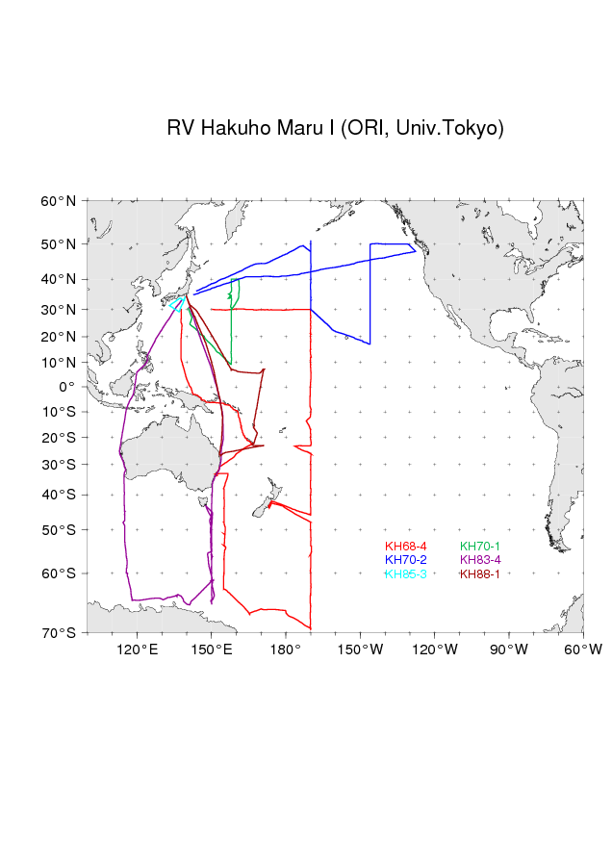
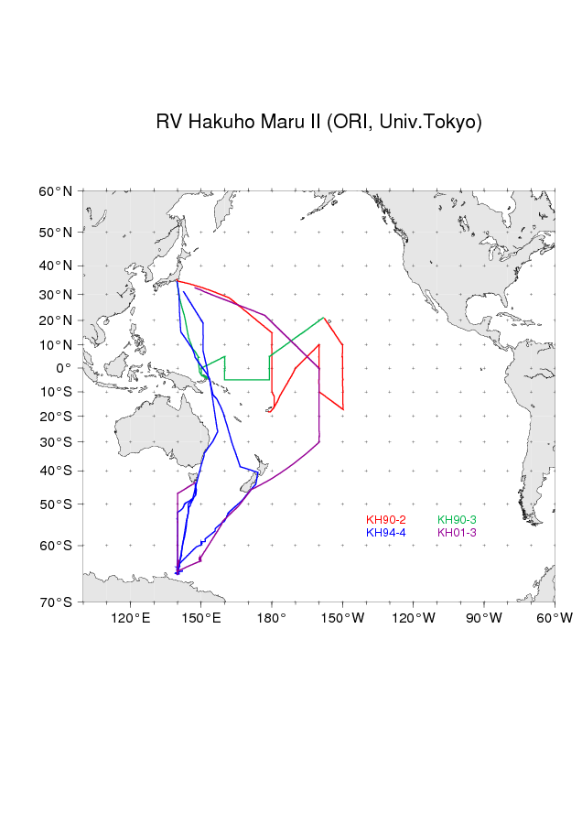
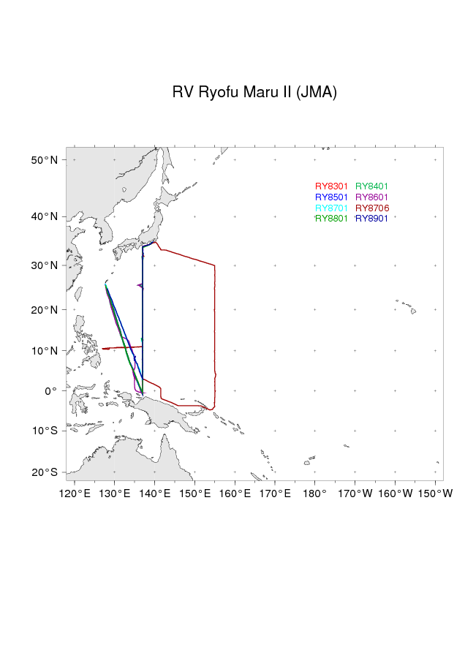
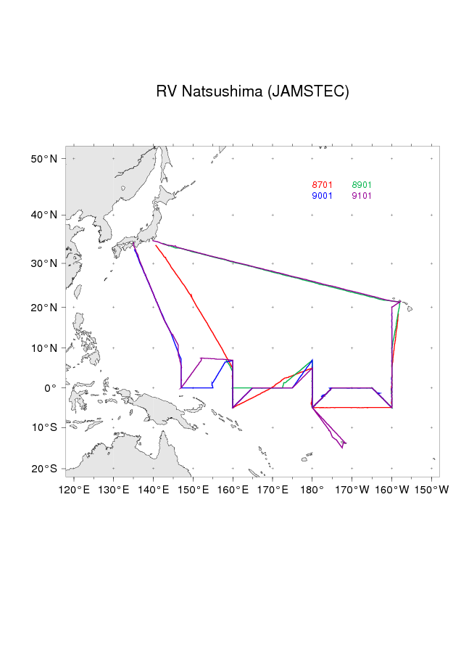
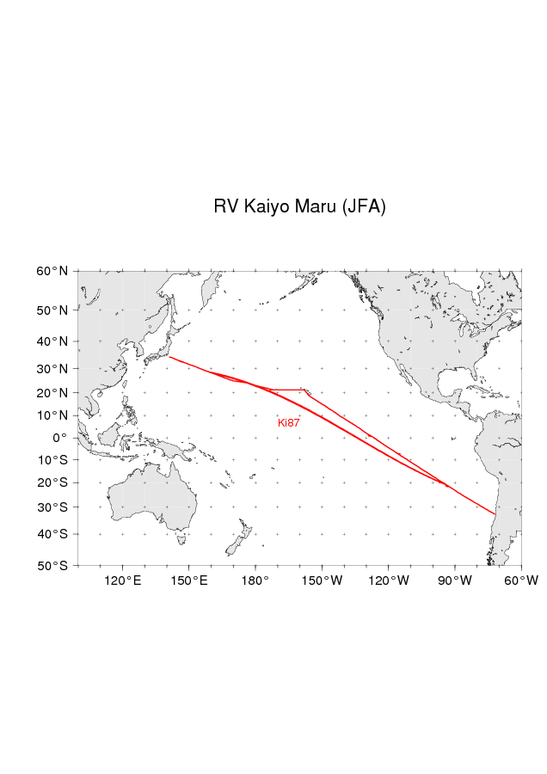
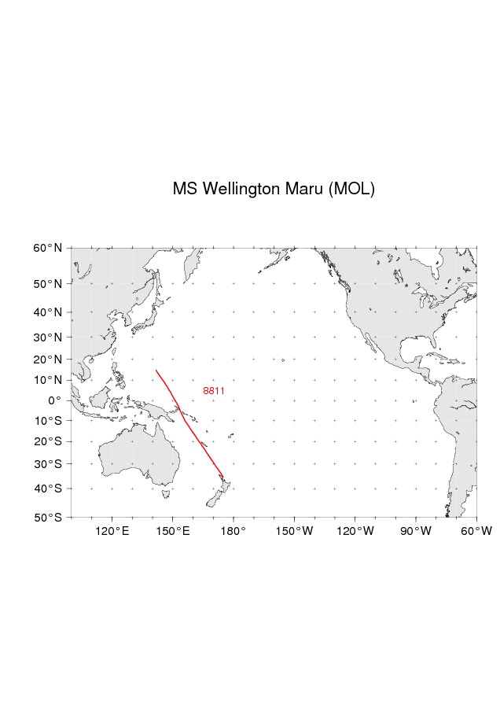
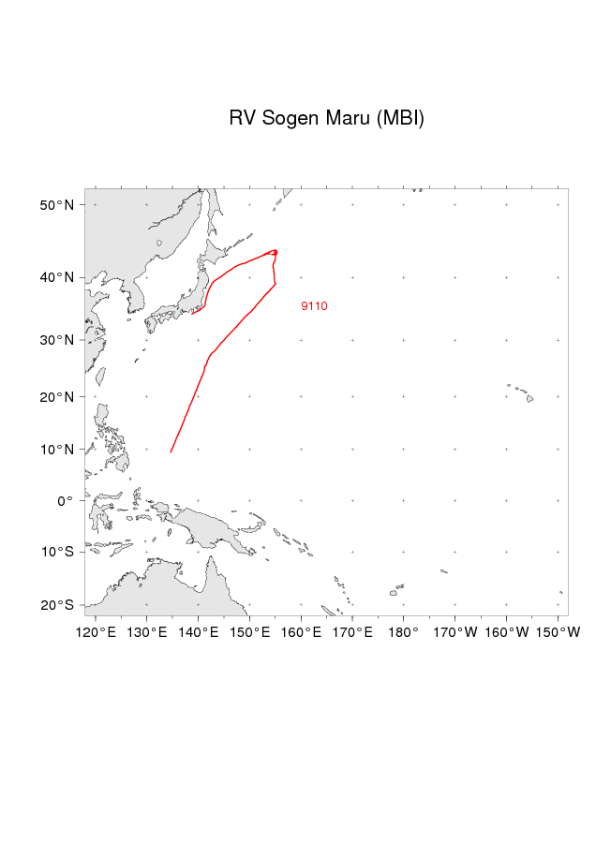
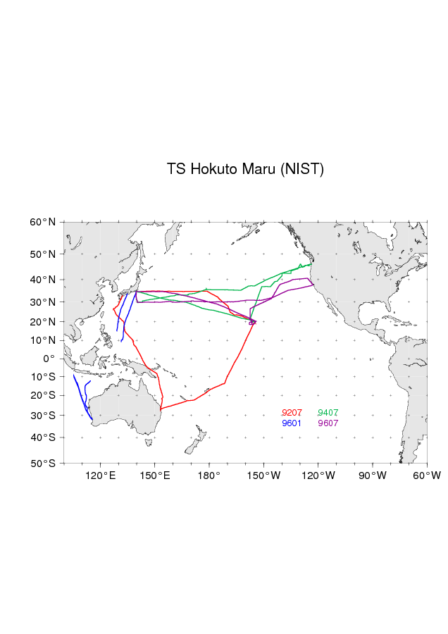
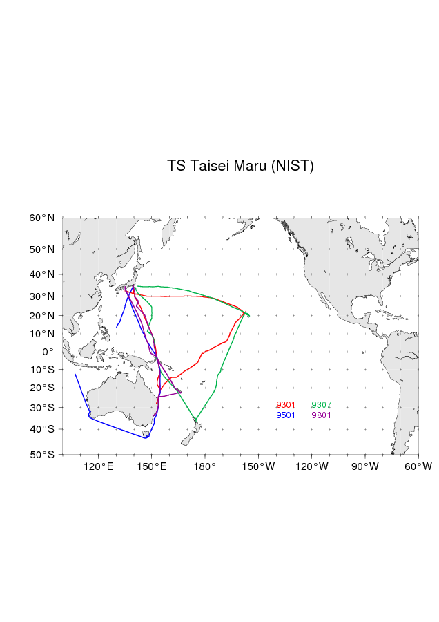
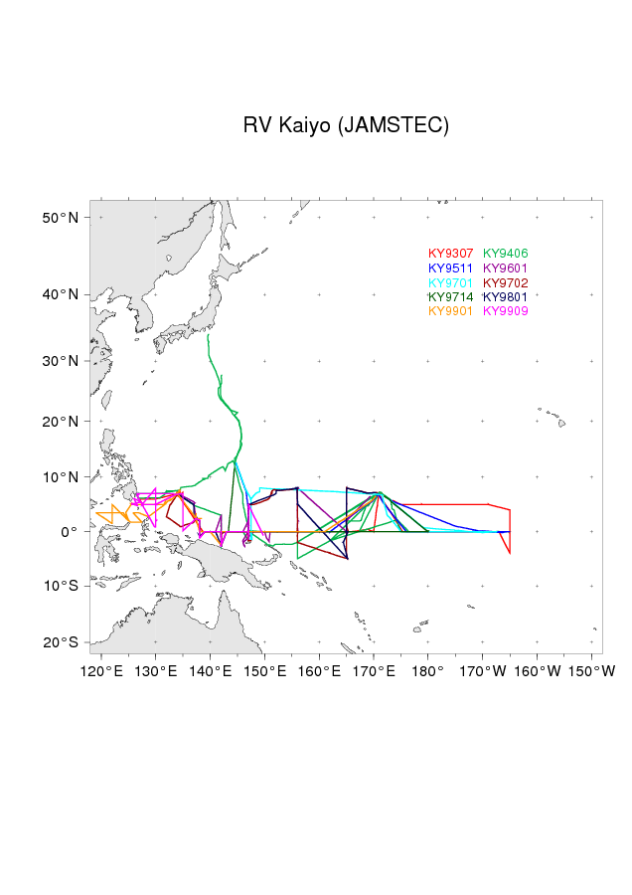
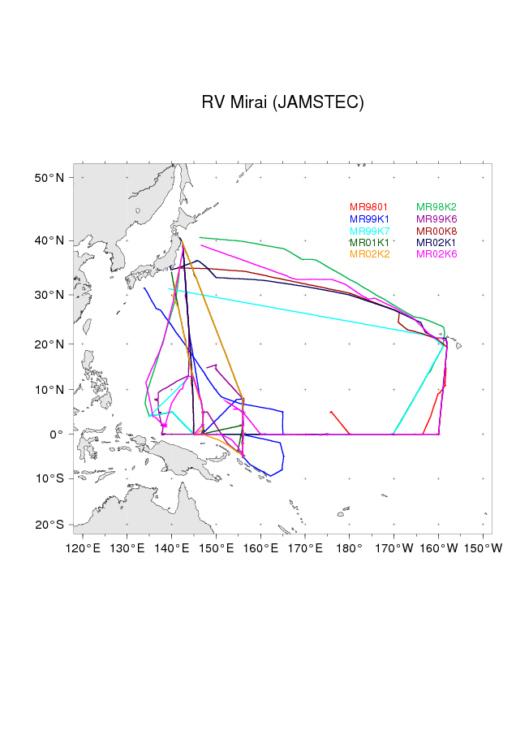
References
- Miyake, Y., Sugimura, Y., Saruhashi. K., The carbon dioxide content in the surface waters in the Pacific Ocean. Records of Oceanographic Works in Japan, 12, 45-52, 1974.
- Inoue, H., Y. Sugimura, Distribution of pCO₂ and δ¹³C in the air and surface sea water in the Southern Ocean, south of Australia, Mem, Natl. Inst. Polar Res., Spec. Issue, 40, 454-461, 1986.
- Fushimi, K.,Variation of carbon dioxide partial pressure in the western North Pacific surface water during the 1982/83 El Nino event, Tellus, 39B, 214-227, 1987.
- Inoue, H., Y. Sugimura , K. Fushimi, pCO₂ and δ¹³C in the air and surface sea water in the western North Pacific, Tellus, 39B, 228-242, 1987.
- Inoue, H., Y. Sugimura, Distribution of the pCO₂ in surface seawater of the western and central equatorial Pacific during the 1986/87 El Nino/Southern Oscillation event, Geophysical Research Letters, 15, 1499-1502, 1988.
- Inoue, H., Y. Sugimura, Distribution and variations of oceanic carbon dioxide in the western North Pacific, eastern Indian, and Southern ocean, south of Australia, Tellus, 40B, 308-320, 1988.
- Inoue, H. Y., Y. Sugimura, Variations and distributions of CO₂ in and over the equatorial Pacific during the period from the 1986/88 El Nino event to the 1988/89 La Nina event, Tellus, 44B, 1-22, 1992.
- Ishii, M., H. Y. Inoue, Air-sea exchange of CO₂ in the central and western equatorial Pacific in 1990, Tellus, 47B, 447-460, 1995.
- Inoue, H. Y., H. Matsueda, M. Ishii, K. Fushimi, M. Hirota, I. Asanuma, Y. Takasugi, Long-term trend of the partial pressure of carbon dioxide (pCO₂) in surface waters of the western North Pacific, 1984-1993, Tellus, 47B, 391-413, 1995.
- Inoue, H. Y., M. Ishii, H. Matsueda, M. Aoyama, Changes in longitudinal distribution of the partial pressure of CO₂(pCO₂) in the central and western equatorial Pacific, west of 160°W, Geophysical Research Letters, 23, 1781-1784, 1996.
- Inoue, H. Y., M. Ishii, H. Matsueda, S. Saito, T. Midorikawa, K. Nemoto, MRI measurements of partial pressure of CO₂ in surface waters of the Pacific during 1968 to 1970 : re-evaluation and comparison of data with those of the 1980s and 1990s, Tellus, 51B, 830-848, 1999.
- Inoue,H., M. Ishii, H. Matsueda, S. Saito, M. Aoyama, T. Tokieda, T. Midorikawa, K. Nemoto,T. Kawano, I. Asanuma, K. Ando, T. Yano, A. Murata, Distributions and variations in the partial pressure of CO₂ in surface waters (pCO₂^{w}) of the central and western equatorial Pacific during the 1997 / 1998 El Nino event, Marine Chemistry, 76, 59-75, 2001.
- Ishii, M., Y. Inoue, H. Matsueda, S. Saito, K. Fushimi, K. Nemoto, T. Yano, H. Nagai, T. Midorikawa, Seasonal variation in total inorganic carbon and its controlling processes in surface waters of the western North Pacific subtropical gyre, Marine Chemistry, 75, 17-32, 2001.
- Feely, R.A., J. Boutin, C.E. Cosca, Y. Dandonneau, J. Etcheto, H.Y. Inoue, M. Ishii, C.L. Quere, D.J. Mackey, M. McPhaden, N. Metzl, A. Poisson, R. Wanninkhof, Seasonal and interannual variability of CO₂ in the equatorial Pacific, Deep-Sea Research II, 49, 2443-2469, 2002.
- Ishii, M., H. Y. Inoue, H. Matsueda, Net community production in the marginal ice zone and its importance for the variability of the oceanic pCO₂ in the Southern Ocean south of Australia, Deep-Sea Research II, 49, 1691-1706, 2002.
- Inoue, H.Y., M. Ishii, H. Matsueda, T. Kawano, A. Murata, Y. Takasugi, Distribution of the partial pressure of CO₂ in surface water (pCO₂^{w}) between Japan and the Hawaiian Islands: pCO₂^{w}-SST relationship in the winter and summer, Tellus, 55B, 456-465, 2003.
- Ishii, M., S. Saito, T. Tokieda, T. Kawano, K. Matsumoto, H.Y. Inoue, Variability of surface layer CO₂ parameters in the western and central equatorial Pacific, Global Environmental Changes in the Ocean and on Land,Eds., M. Shiyomi, H. Kawahata. H. Koizumi, A. Tsuda, and Y. Awaya, TERRAPUB, Tokyo. 59-94, 2004.
- Inoue, H.Y., M. Ishii, Variations and trends of CO₂ in the surface seawater in the Southern Ocean south of Australia between 1969 and 2002, Tellus, 57B, 58-69, 2005.
- Midorikawa, T., K. Nemoto, H. Kamiya, M. Ishii, H.Y. Inoue, Persistently strong oceanic CO₂ sink in the western subtropical North Pacific, Geophysical Research Letters, 32, No. 5, L05612, 2005.

